|  |
| --- |
| Climbing and General Training Tracker |
|  |

Table of Contents

Analysis 2

The Problem: 2

The stakeholders: 3

Solving the problem computationally: 3

Abstraction: 3

Decomposition: 4

Thinking Ahead: 4

Logistics: 5

Procedural and Object-Oriented Thinking: 5

Conclusion: 5

Software and Hardware Requirements: 5

Limiting Factors: 7

Research: 7

Interview: 7

Existing Solutions: 9

1 – Crimpd: 9

2 – Gym Tracker: 10

Questionnaire: 11

Proposed Solution: 13

Success Criteria 14

DESIGN: 17

Website Arrival: 17

Login: 17

The Website Flow Chart: 18

19

Question Pages: 19

19

My Plan: 19

My Progress: 21

Start Exercise / Today: 21

22

Stopwatch: 22

Navigating The Website: 22

Logout Button: 23

IMPLIMENTATION STAGE 23

Processes in the website: 23

Git Repository: 24

Initial Approach: 25

External Style Sheets: 26

Switching between Login and Signup: 27

XAMPP: 30

Database: 31

The User_Table: 33

Signup: 33

Login: 36

Question Pages: 37

Sessions: 41

Login Bugfixes: 41

My Plan Page: 42

Plan Maker: 43

# Analysis

## The Problem:

For my project, I am designing a website where a user can create an account and the website will develop a climbing training plan. This will be similar to existing programs such as Crimpd (https://www.crimpd.com) and other general gym tracking apps (https://www.strong.app). The website can analyze and suggest better ways to train for the user’s needs. On creating an account, the user can specify their goals and the website will tailor their climbing and training to their needs.

The overall goal of the website is to enhance a climber’s training structure and exercise efficiency. This will allow climbers to use the resource to develop their skills faster and with less injury.

The reason I am making this website is that climbing training plans and information is hard to understand and incoherent to implement without paying money for professional trainers, this makes climbing training hard to begin and understand. My resource will allow all levels of climbers to train with consistency and understand which exercises to do and why.

For this to function the website must have an easy user interface for users to quickly navigate to what they need. The website will also need a database to store users’ login details to allow personalized experiences.

On arrival to the site, users will be prompted to log in or signup, after signup users will have an optional quiz that will tailor the website’s suggestions to the user. Then users will be shown options such as account, logbook, exercise finder, and my plan. Users can follow these options to navigate to which feature they wish to use.

## The stakeholders:

The project will be accessible to all internet users who use a web browser, this means this won’t limit most potential users. The main user base will be experienced climbers who are looking to structure their training to improve or maintain strength. However, the website will also be useful to other sporting athletes who want to track and organize their training.

The target audience is climbers looking for a free method to further their training. This will mean my main audience will be experienced and/or dedicated climbers with an interest in improving.

There should be few language and other interaction complications since being a website the language can be translated by the browser. This mean the limit to my audience is the number of interested climbers.

I’ve selected a potential user to represent my target audience, Ben Cook. He’s a 17-year-old climber with a few years’ experience in climbing training. He has a large interest in climbing training but has never used structured plans due to the accessibility limits such as money and time. Due to this ben has struggled with numerous injuries and plateaus during his climbing. Using a free climbing plan maker Ben will be able to organize his training and avoid injuries and maintain stable progress.

I have frequent contact with Ben since we climb together on a regular basis this will allow me to update and adapt my product as its being developed to make sure it is tailored to the potential audience.

## Solving the problem computationally:

My problem is well suited to computational methods of solving problems since computers are quick and optimized for algorithms such as recommending exercises to users and well as providing an easy and quick method for users to access the resource.

### Abstraction:

Abstraction is a method of removing elements of code or programs that aren’t relevant or important to the main purpose of the program. For my problem, I’ll ignore the styling and appearance of the website while I focus on the basic functionality such as the database and algorithms working. I will also focus on more important functions such as login and sign-up services and the climbing logbook.

Abstraction is also hiding data useless to users and code from the user this involves a fluid experience for the user through a GUI. Users won’t be able to see code and how the website works such as the code to optimize training plans and suggest exercises. Users will only see the outputs from the code.

By coding the most important functional aspects of the site first I’ll ensure that I follow a direct order of programming and be able to test later website functions without limitations as the backbone programming is already there.

In my program, I will abstract the following and more:

* Simplistic layout only shows items relevant to the current page
* Hamburger menu to allow navigation
* Showing progress in a simple graphical form
* Plan will be designed on a weekly rotation
* Personalization algorithm will work of simple answers (multichoice, yes/no, scale)

### Decomposition:

I will need to use decomposition to help me effectively complete the website. Decomposition is the method of breaking down problems into simpler, smaller tasks. This helps make problems easier to approach and complete as its easier to focus on smaller manageable parts than trying to do it all at once.

For example, when coding algorithms for login I will focus on individual elements then put them together such as visuals then database then input. This will make it easier to focus on the purpose of the code I am writing and help keep code modular.

When decomposing the development of the home page I’ll separate it into these main parts:

* Home page design
* Login feature
* Additional Links e.g. forgot password button
* Username and password storage
* Username and password login checker

For the home page design ill need to consider the useability and appearance the page should be visually interesting but also easy to interact with.

I plan to store usernames and passwords in a database. I will hash the password before storage and then to check the password I will hash the inputted password and compare the two hashed passwords.

I’m adding a forgot password button to make the site more accessible, if users forget their password, they will still be able to gain access to their account after proving their identity.

For all navigation on the home page, I will use JavaScript to provide functionality without having to reload the website. This will make the page more appealing to users especially people with slower internet.

### Thinking Ahead:

Thinking ahead is a way of planning a method of producing a program such as deciding on features and methods beforehand.

* I will program as a website as I have experience with creating functional websites and it provides access to the program without download.
* For the languages I will use the normal network stack, HTML, CSS and JS. However, I will also use PHP since I have a lot of experience with PHP and it is very effective at modelling data and interacting with databases.
* The outputs from the site will be visual and inputs will be mostly buttons.

### Logistics:

Navigation on the website will be mostly mouse based with large buttons to click on with short descriptions more detailed information will be displayed after navigating to specific pages. During workouts, the site will use sounds to present time, reps, and sets to allow users to complete workouts without watching their phones.

### Procedural and Object-Oriented Thinking:

The method of thinking about code can either be procedural, object oriented or both.

Procedural think involves breaking down a problem into smaller problems as described in decomposition and coding each of these mini problems as callable functions. This limits the need for code to be repeated and makes debugging easier since each function does a specific task.

OOPs model organizes design around data as objects and defined how objects interact with each other rather than functions and logic. Each object has its own attributes and behavior.

For my website I will use a mainly procedural approach but incorporating OOP in certain algorithms such as connecting to the database and creating the user’s plan. Using OOP to create the users plan makes sure the user’s data is handled safely and is encapsulated. It also means that multiple plans can be created as different objects without having to repeat code or use while loops.

### Conclusion:

The examples above demonstrate how solving this problem via computational methods is appropriate. Using computers to solve this problem is highly effective and efficient, making it much easier than alternative methods such a pen and paper.

If my solution is effective users and stakeholders will be able to use my website to generate a tailored training plan to help them improve their climbing while reducing the risk of injury.

## Software and Hardware Requirements:

Due to the nature of websites the requirements for using the website are minimal. Users will need an internet browser and an internet connection. Minimal hardware specs are necessary. The website is using mostly JavaScript rather than many webpages this reduces the need for the website to reload constantly.

Hardware requirements:

|  |  |
| --- | --- |
| Hardware Requirement | Justification |
| Monitor or other digital display | To display the website |
| Mouse or Touchscreen | To interact with website |
| Pentium 4 processor or better | To meet standard web browser requirements |
| 100MB Secondary storage space | To meet standard web browser requirements |
| 128MB RAM | To meet standard web browser requirements |
| Windows 7 or Higher (IOS 10.5.6, Linux released after 2010) | To meet standard web browser requirements |

Software Requirements:

|  |  |
| --- | --- |
| Software Requirement | Justification |
| For general usage of website, no additional software is needed that is not included in the default web browser. | Web Browser to access and load website |
| For Designing and Coding the Website | |
| XAMPP | To Host webserver and database |
| Apache | Included in XAMPP, webserver host |
| MySQL | For the Database |
| Visual Studio or alternative editor | To write and edit code. Additionally provides debugging and other IDE extras |
| Web Browser | To Open webserver |
| Git (optional) | For version control |
| PHP | So that PHP can be run |
| Optional extensions to be used during development | |
| CSS Peak | Easy of coding CSS |
| Git Graph | Easy of version control |
| HTML & CSS Support | Additional html and CSS debugging tools |
| IntelliSense for CSS | Easy of CSS coding |
| Jupyter and extras | All around ease of coding improvements |
| Live SASS compiler | To convert SASS to CSS where needed |
| Path IntelliSense | Ease of PHP coding |

## Limiting Factors:

A limiting factor is the school internet, I will primarily be coding on visual studio and the internet blocks many features that make coding easier such as certain extensions.

To get around this challenge I will install all extensions I need at home.

## Research:

### Interview:

The interview will be with my stakeholder and will allow him to influence the features that could end up in the final product. I’ll be asking him simple questions that will allow me to understand what is necessary for the website. Ben’s answers are shown in a different colour and have been condensed to bullet points for simplicity.

**What would you like the website to take into account when designing your plan?**

* **My Availability**
* **My Goals**
* **My experience**
* **My Current Weaknesses**

**Is tracking individual exercises and performance overtime important to you?**

* **Yes**
* **Tracking progress of exercises is important**
* **Progress should be easy to see by putting it on a graph or table**

**What are your favorite features of other solutions you have used previously?**

* **A Timer**
* **Lots of exercise choice**
* **Descriptions for exercises**

**Is it useful to still have options to manually edit your plan?**

* **Yes**
* **Being able to swap days is useful**
* **Being able to change exercises is essential**

**Is the presentation of the training plan important to you?**

* **Sometimes**
* **Functionality is more important**
* **Display should be simple and to the point**

**What is the most important feature for the training tool besides making the plan?**

* **Being able to view the individual day I am on so I don’t have to think too much when I want to start training.**

**How many exercises should be the max per day?**

* **7**

**How many days should be the limit for a week?**

* **5**

**How many strength training days should be the max?**

* **3**

**Is a login system important?**

* **Yes**

**Is the login screen presentation important?**

* **Yes**

**Should the login screen be simple or have lots going on?**

* **Simple with a relaxed design**

**How should the plan be displayed?**

* **Day by day**
* **As a table or list**

**Timer or Stopwatch?**

* **Either, both are useful**

**Collect history or all exercises?**

* **Yes**

**Is a password confirming box important for the signup page?**

* **Yes**

**Should the signup page look similar to the login page?**

* **Yes**

### Existing Solutions:

#### 1 – Crimpd:

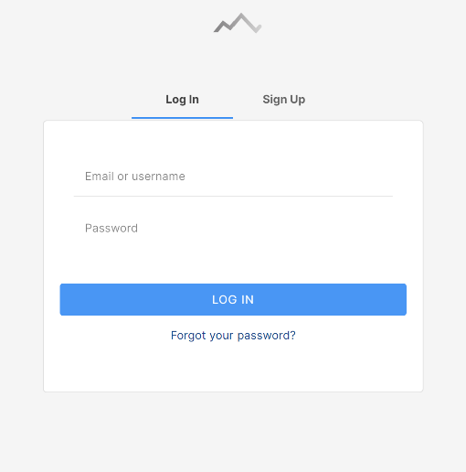Crimpd is an existing climbing-specific training app. Crimpd provides users with a selection of workout movements and short workouts, Users use multiple of these in conjunction to create a full workout session. Crimpd also provides a detailed graphical display of progression and a point system to show users how much work they have done in each aspect of climbing.

This is Crimpd’s login/signup page it’s very simple and directs users’ attention towards where to input data this makes login and signup quick and easy. In my site I will use a simpler design on the signup page.

Having a simple signup page with limited questions upon initial site arrival will present the program as simple to use which makes it more approachable to potential users.

They also have an easy to find “Forgot your password?” which improves verification of user via email confirmation.

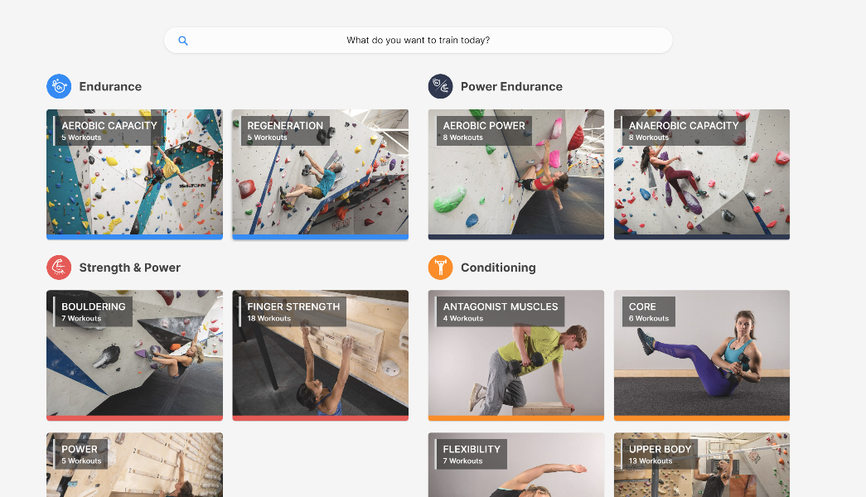This is Crimpd’s home page, it is divided into types of workouts with simple names and logo coordination. This makes it simple to find a specific workout to complete.

Color coordination makes it easy to spot what component of climbing your training and helps locating specific components when in different exercise views.

By having simple photos of exercises as backgrounds it makes it easy to understand what an exercise is and allows beginners to understand what the name of an exercise means.

They use abstraction to hide unneeded details such as workout description and equipment since it isn’t needed when briefly looking at what area of climbing to work on.

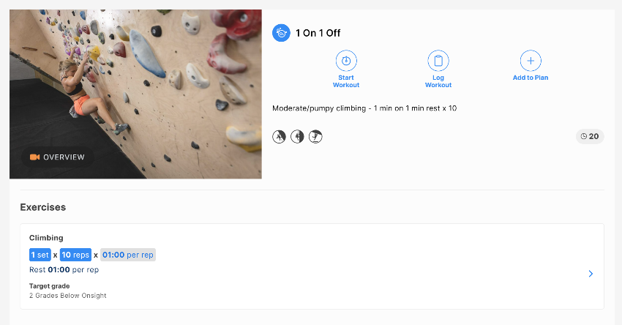This is the page shown when clicking on a specific exercise, in here they show all the details to the user since it’s no longer to abstract and hide data. There are 3 main buttons clearly labeled and visible. This makes it easy for users to know where they can navigate off the page.

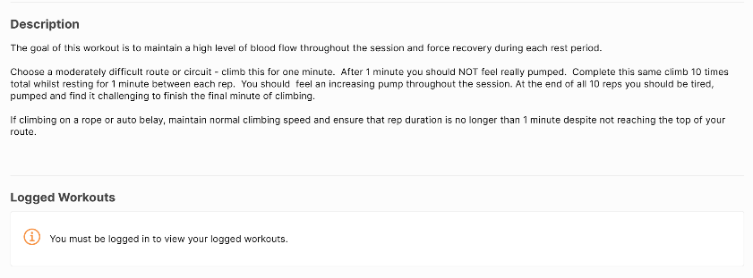It also has a demonstration video available to watch, this makes it easier to understand for users. They also have a basic description of sets, reps and times. This makes it obvious how long a user will spend on an exercise.   
They also provide a brief description of what the exercise achieves and how to perform it. This makes it clear for anyone who is new to training or prefers words over the video.

#### 2 – Gym Tracker:

Strong gym tracker is a non-specific training app tailored to Apple and IOS. It doesn’t have a website of desktop app but has android and IOS apps on their designated stores. Strong also improves its accessibility by making it work on Apple Watches which for some 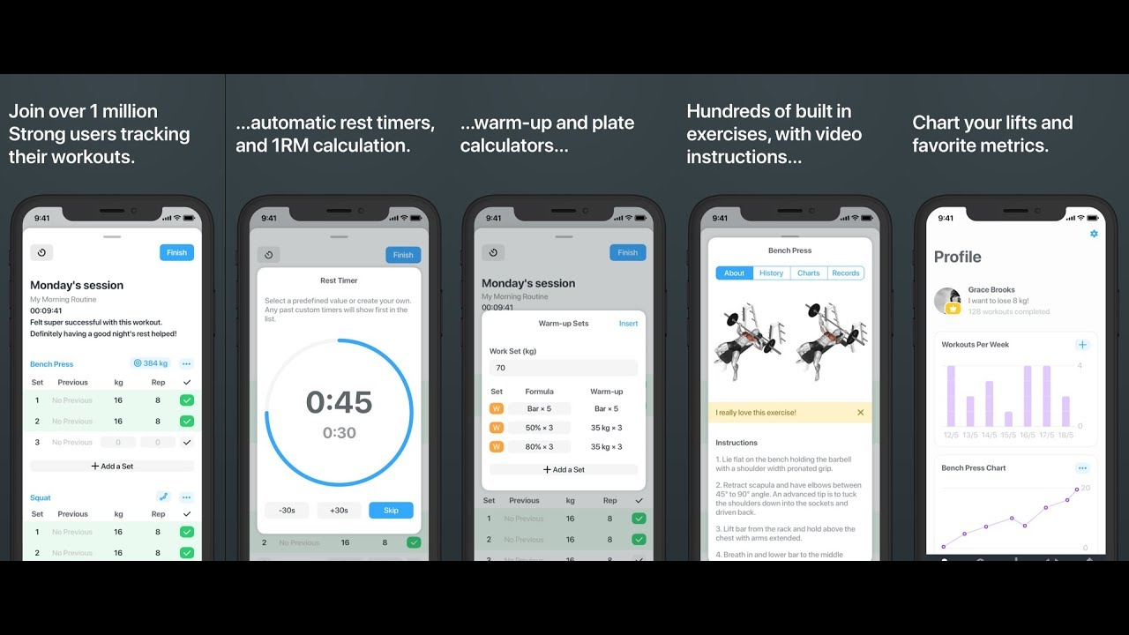people can make it easier and quicker to view and interact with the service.

Strong workout provides a plethora of features with a sleek and clean user interface which promotes ease of use.

### Questionnaire:

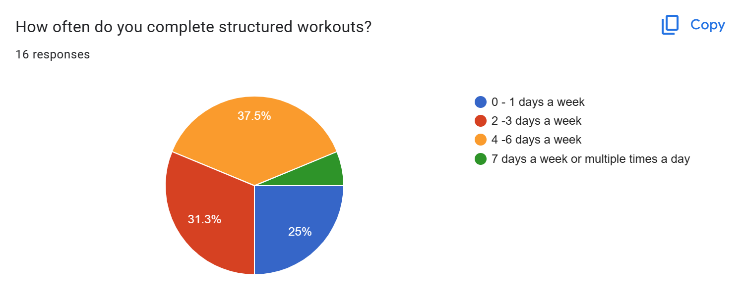I conducted a structured google form questionnaire and collected responses from my class and other students. This will help me understand my markets needs and wants. I’ll use this information to improve my website design.

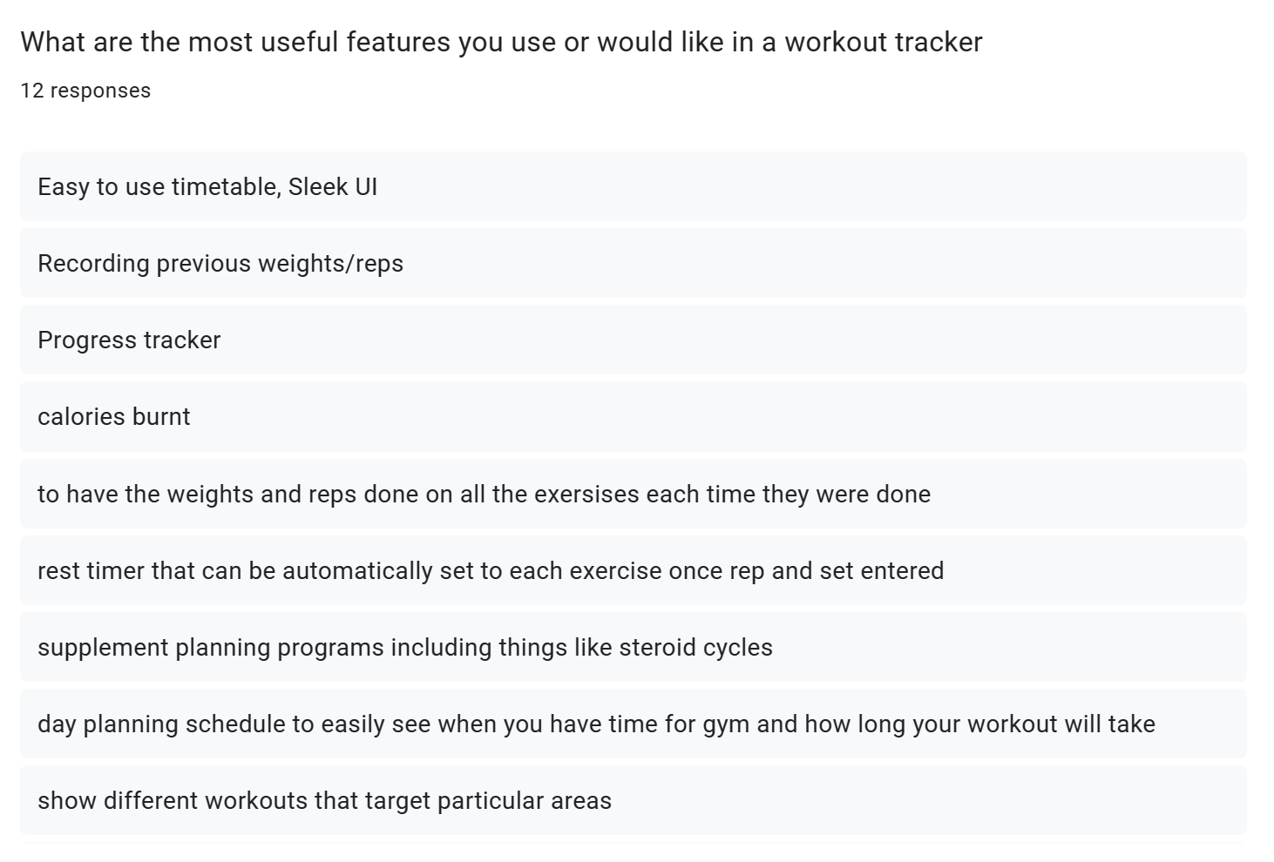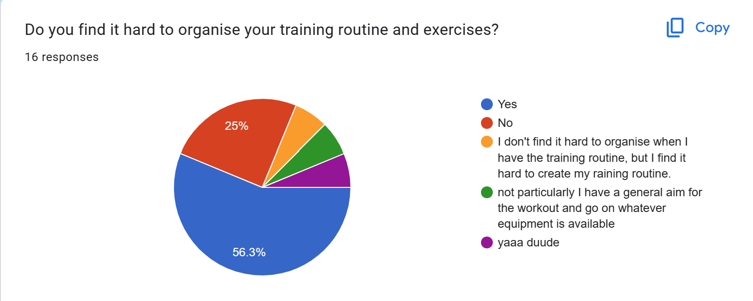This shows that that there are many potential candidates for my program. However, this is off a small sample so the results may be unrepresentative of the whole population.

These are some of the feature suggestions for the website. I will try to incorporate as many of these as possible however these ones I won’t:

1. Calories Burnt – I won’t incorporate this since the website can be used on any internet device and most likely won’t be a wearable. Collected data won’t be specific enough to provide users an accurate calorie figure.
2. Progress Tracker – I’ll use occasional testing to track progress for users and normal workouts can be used to track progress. Data will be shown on graphs since it is more visual for users.
3. The website will suggest reps and sets for all exercises and will help with rep and rest timings to help usability.
4. 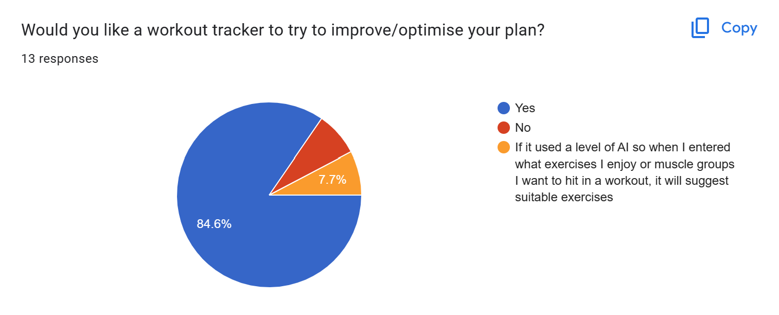Supplement and diet programs won’t be included in the app as my knowledge in these areas is limited.

The responses to this show there are reasonable demand for a product like mine.

## Proposed Solution:

These are the main features proposed for the website as learned from the questionnaire, interview and previous solutions.

|  |  |
| --- | --- |
| Login Page | Simple, maybe a picture background. Focus on the login area no clutter. |
| Signup Page | Similar style to login page. Password confirm is important. |
| Question Pages | Simple, questions: Availability, goals, experience, areas to improve. |
| Plan Algorithm | 3 strength days max, 5 days total max, should tailor using questions. 7 exercises per day. Lots of exercise variation. |
| My Plan page | Simple display, table or list. Should allow manual editing of plan. Include exercise descriptions. |
| My Day page | Shows individual page, allows tracking of each exercise. Stopwatch or timer here? Simple display like My Plan page. |
| My Progress page | Graphical display of progress for all exercises |
| Stopwatch Page | Stopwatch and timer |

## Success Criteria

|  |  |  |
| --- | --- | --- |
| Criteria | Justification | Reference |
| Index Page | A landing page for the website | Feature of all websites |
| Login Page | An area for users to login to their personal account | Interview, Feature from existing solutions |
| Signup Page | An area for new users to create an account | Feature existing solutions |
| Questions Page | Place for users to answer questions needed for the plan generator to function | Interview |
| Max 3 strength training days in plan | Avoids overtraining | Interview |
| Max 5 total days in plan | Avoids overtraining | Interview |
| Max 7 exercises per day | Avoids overtraining | Interview |
| Question about availability | Allows algorithm to know the user’s availability | Interview, questionnaire |
| Question about goals | Allows algorithm to know the users focus | Interview, existing solutions, Questionnaire |
| Question about experience | Allows algorithm to know the users experience | Interview, Questionnaire |
| Logout option throughout website | Let’s user’s logout of their account at any point in the website | Interview, Existing Solutions |
| My Plan Page | Page to display users training plan | Interview, Existing solutions |
| Plan displayed as table or list | Makes plan easy to read | Interview |
| Plan separated by days | Makes plan easy to understand | Interview |
| Simple Login and signup page | Makes process easy to follow when logging in of signing up | Interview |
| Manual editing of exercises in plan | Means users can manually tailor their plan to their preferred exercises | Interview |
| Manually editing of days in plan | Users can rearrange plan days to suit their needs | Interview |
| Each exercise has a description | Helps used understand how each exercise should be performed | Interview |
| Individual day page | Shows the user the training scheduled for today | Interview, Existing solutions |
| Save data from workout | Allows user to track progress and avoid plateaus | Interview, Existing Solutions |
| Progress Page | Displays the users progress over time | Interview, Existing solutions |
| Progress displayed as list or graphically | Makes understanding the data collected from exercises easier | Interview |
| Stopwatch page | Allows user to measure exercises | Interview |

# DESIGN:

## Website Arrival:

On arrival to the website, users will be asked to log in using their username and password or signup. During signup, users will be asked questions in a multiple-choice style.

Usernames, question answers and the hashed password will be stored in a database.

Questions will include clients:

* Time/Availability
* Goals
* Experience

This data will be stored in the client’s profile and will be editable at any time. After the data has been collected it will be used to create a custom training program for the client. This program will be customizable manually also.

The login page will be simplistic and will have a forgot password button to improve accessibility.

## Login:

The login page will be the index page for my website as users will need to login or signup before having access to features. This is because the features of the website require data about the user to be useful.

If users have an account, they will be able to login by entering a username or password. If the user forgets their username or password their data will be recoverable if they can enter either the username or password and answer security questions, they enter upon creating an account.

When a new user arrives on the login index page, they will be able to switch to the Signup page by clicking a button. This will bring them to a similar page where they can enter a username and password plus a password confirm field is required.

The username and password have a few validation requirements. The username must be composed of only letters and numbers and have no spaces. The password should be at least 8 characters in length and should include at least one upper case letter, one number, and one special character. This not only makes the password more secure but allows the data to be handled easier as it has already been validated before being stored a database.

All passwords and security questions will be stored using hashing for security, if someone accesses the database unauthorised then they will not have access to personal data. To 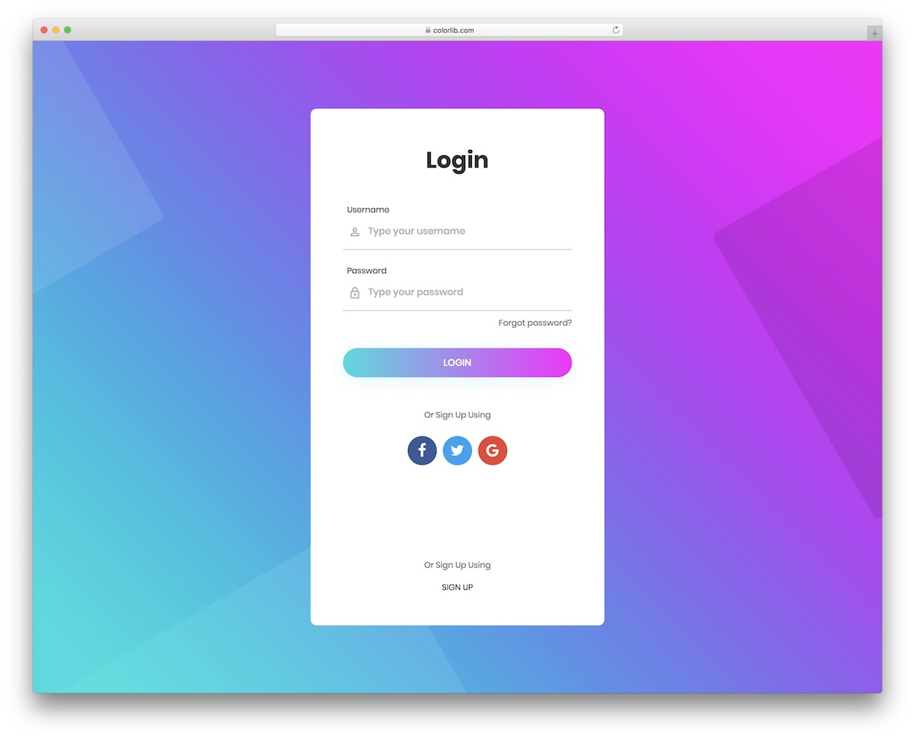check that an inputted password matches the hashed password the input will be hashed also then the two values compared. For security questions the inputted value will be converted to all lower case and remove any punctuation before being hashed. This means if the person trying to input their security questions types a slightly different grammar the database will still match the hashes and grant them access.

The image above in an example of a login page I will used as a template for designing my own page. My own version will not have options to login using other methods. This template is good as the fields are obvious and the UI is easy to understand will still being visually interesting.

When a user creates an account, they will be prompted with a variety of questions which will be stored in a database. The answers to the questions will be used by an algorithm to make a tailored plan for the user. Information provided by the user will be editable at anytime via the account section later. Some possible questions are below:

* How many days a week are you available?
* How many hours on each day are you available?
* What is your current training focus/goals?
* How much training experience to you currently have?
* What equipment do you have available?

Users will also be prompted to input data such as current weight, height and also current PBs and records they have is certain lifts/exercises.

## The Website Flow Chart:

## 

Above is my website walk through. Users will also be able to logout at any stage of the website. This will redirect you to the login page. The green boxes show what must happen upon loading the page.

## Question Pages:

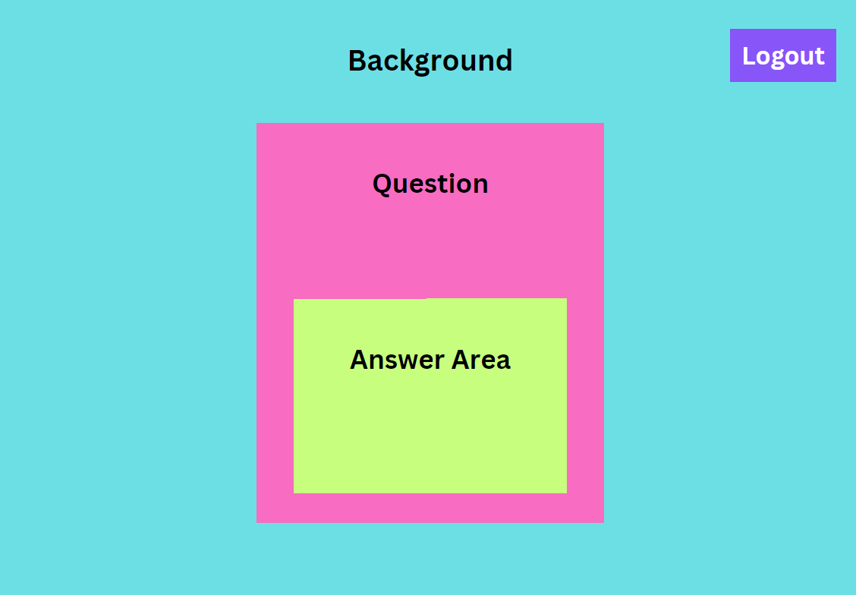The question pages will be very simple with the focus being on the question. To apply this the question pages will have similar appearance to the login page with a simple background and a content section in the center where the question and an answer area are displayed.

A logout button will also be in the corner so that users can logout during the question answering process an come back to it later. If the user clicks this button they will be redirected to the login page.

## Fitness App Review: My Workout Plan by Sosis Apps - Dammit Karen

## My Plan:

Users will have access to their plan to view or edit details. In this area, they are presented with a calendar on which are events for workouts. When selecting an event, they can edit manually or run the workout manually which directs them to the start exercise page.

In this area options selected for the plan creator can be edited also.

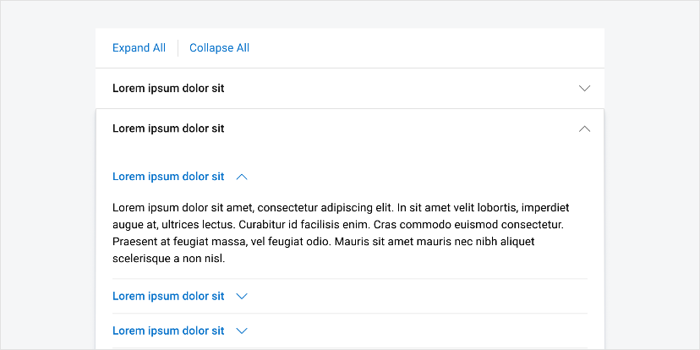Similar to the example on the right where each day is displayed in a list style for users to see. I will design a similar solution for this page that will allow the user to easily understand their plan.

In this area users will also be able to expand exercises to get a description and more detail. An example of how this will work is in the lorem Ipsum example on the left. Using an accordion style bar for each exercise the user can click on an exercise and then any additional information can be displayed in the expanded accordion.

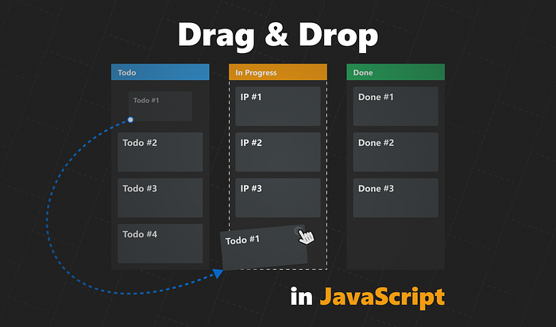When a user edits their plan manually the json file containing the plan will have to save these changes so that they will be kept upon a refresh. If the user changes two days around they can be swapped in the json file. If the user swaps out an exercise or adds a new on the exercise must be located in the exercise directory json file and then all its details can be added to the training plan in the correct place.

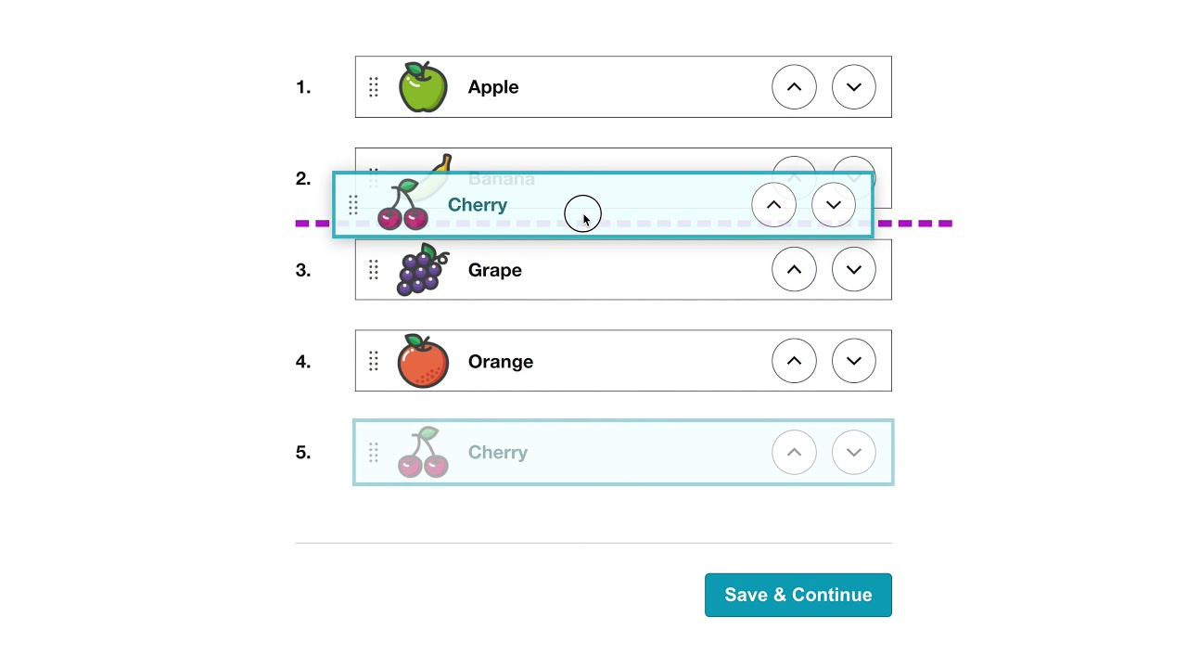To move exercises and items around the plan users ideally will be able to drag and drop individual items and move them to the desired location. However, the implementation of this will be difficult and if this becomes too difficult to code another solution will be for users to select two exercises or two days and select a swap button to swap their positions. Similarly, to add exercises users can select a location and select an add exercise button. The idealistic solutions are shown in the pictures above where users can drag and drop items to rearrange them.

## My Progress:

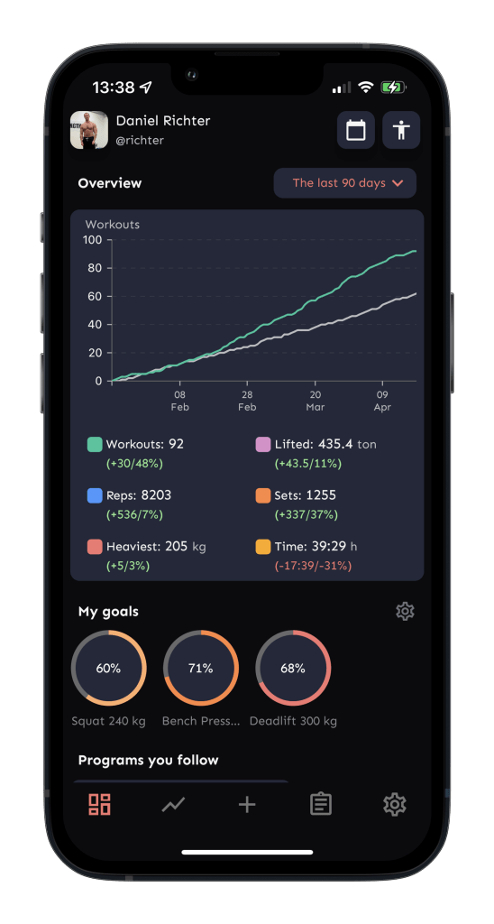This area will present statistics in the form of various charts. These can display work out details such as workouts per week and details such as workouts for strength or endurance. Progressions can also be displayed using data collected at the end of workouts and on monthly standardized evaluation days.

This area is useful for users to visually see them progress which is important for motivation. This data is also useful to the program to continually update the plan and suggest improvements.

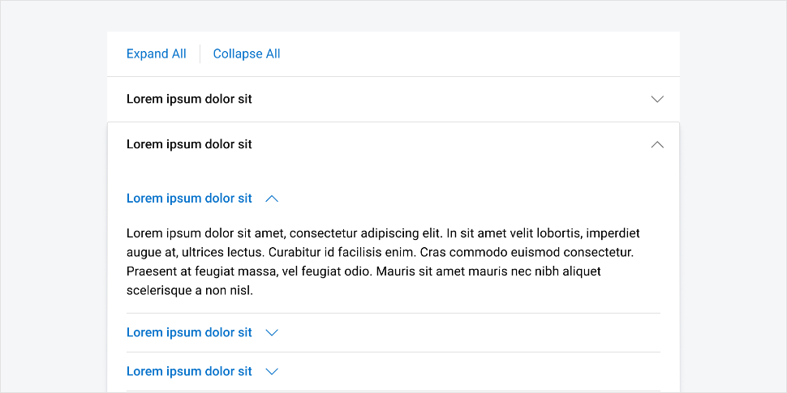My design will be similar to the solution on the left however my solution will additionally show the progress users make on individual exercises.

Simularly to the My Plan page each exercise will be expandable via a accordian menu. Each exercise will have an accorian item and when clicked on will open to display the progress information about the exapanded exercise. The expanded info will contain the graphical data and or a list alternative. An accordian menu is the best solution for this since over the course of training plans the user will collect information about many exerices and displaying all exercises graphs and data at once will be overwhelming and hard to understand for users.

Another solution would be to display the most frequently erformed exercises and add a search bar for users to find their desired exercises if they are no aready displayed.

## Start Exercise / Today:

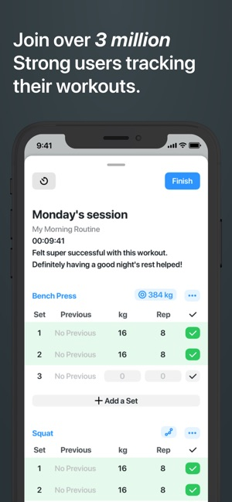This page will show the exercises that will be done today and allow the users to log the difficulty the exercises were completed at, this can be stored and pulled up later in the progress section.

The example solution on the right is from a generic gym workout tracker this will be similar to my solution.

This area will also give more in-depth explanations on each exercise including a description, sets and reps for each exercise. This will be displayed in a table where each exercise can be expanded for more details.

To submit the exercise difficulty the user can click a button that will submit the individual exercise once submitted and sent to be stored the option to submit will be greyed out and users will not be able to submit and more of the same exercise unless it is planned to be in the day more than once.

On the ‘My Plan’ page the user will be greeted with a day by day breakdown of their plan in a list style layout. This is simular to the strong app example on the right. Strong allows users to log workout info and change sets and weight in this area, however I will have this functionality on my ‘Today’ page. The ‘My Plan’ page is purely an area to view the overall plan and decide if you like it. Upon loading this page for the first time the users plan will be generated and saved. If the user doesn’t like their plan they can choose to regenerate the plan via a button at the bottom. Alternatvley will be able to manually edit exercises or move days around to fit their needs.

### 

## Stopwatch:

There will also be a simple stop watch page which the users can use to assist in tracking exercise performance. The stop watch will have large numbers for readability, there will be a start, stop and reset button to control the functions on the stopwatch.

## Navigating The Website:

The website will be navigated via a hamburger navigation bar which will open to the center of the screen and cover hide the rest of the website behind. Page navigation options will be similar to the presentation below. The logout option will also be available here.

When hovering on the hamburger icon the icon will change colour to show the user that it is a clickable button. The user’s username will also be on the navigation bar the user knows what account they are logged into. When clicking on the users name it will relocate the user to the main ‘My Plan’ page.

## Logout Button:

On every page in the website apart from the login and signup page there will be a logout button or option. This will allow users to end their session, this is important for the user’s data protection.

On the question pages a logout button such as on the left will be displayed in the corner, this can be clicked to log the user out.

On other pages such as ‘My Plan’ the user can logout via the navigation bar. The last option in the navigation bar will be a logout option that will end the user’s session.

After logging out the user will be redirected to the login page.

# IMPLIMENTATION STAGE

## Processes in the website:

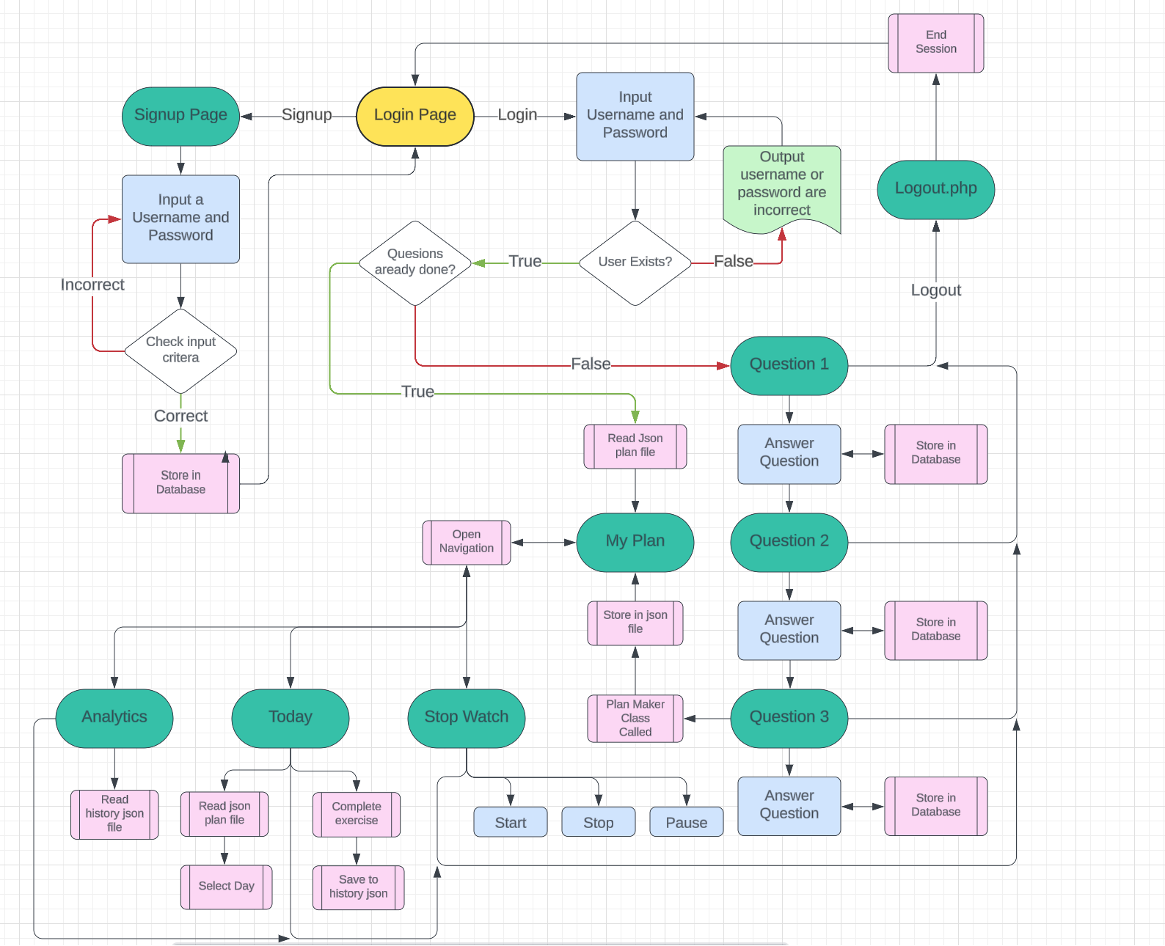Below is a more in-depth map / flowchart for the processes inside the website this shows decisions and subprograms that will be run at different points throughout the website. Users will start at the index page that is the login page. Here users can login or navigate to the signup page.

## Git Repository:

For my project I decided to use git as a way of managing versions and being able to keep track of my decisions and progress over time. I created a GitHub Repository that stores all the fields from my project. This also allowed me to roll back to previous versions easily if things break during coding.

## Initial Approach:

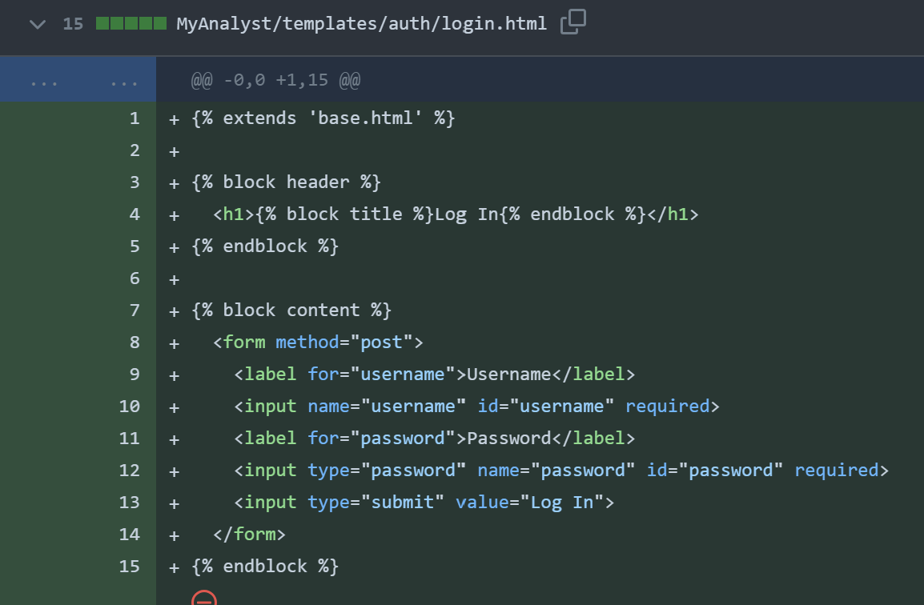My initial solution for my website was to use flash which is a web framework built around python. I chose this since I had experience and knowledge of python and would not take much learning to adapt to flask.

After experimenting with flask and building some basic pages to experiment with flask I decided that my original approach discussed in the analysis was better and I switched back to the normal web stack.

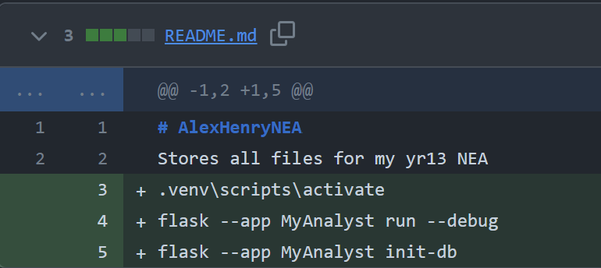On the left was my basic login page created using flask. This worked as intended but lacked functionality. After this experiment and also creating a signup page is decided php and normal web stack was more suited to my design needs.

During using flask as a solution I saved all he commands I frequenty needed to run my project into the readMe file for ease of use.

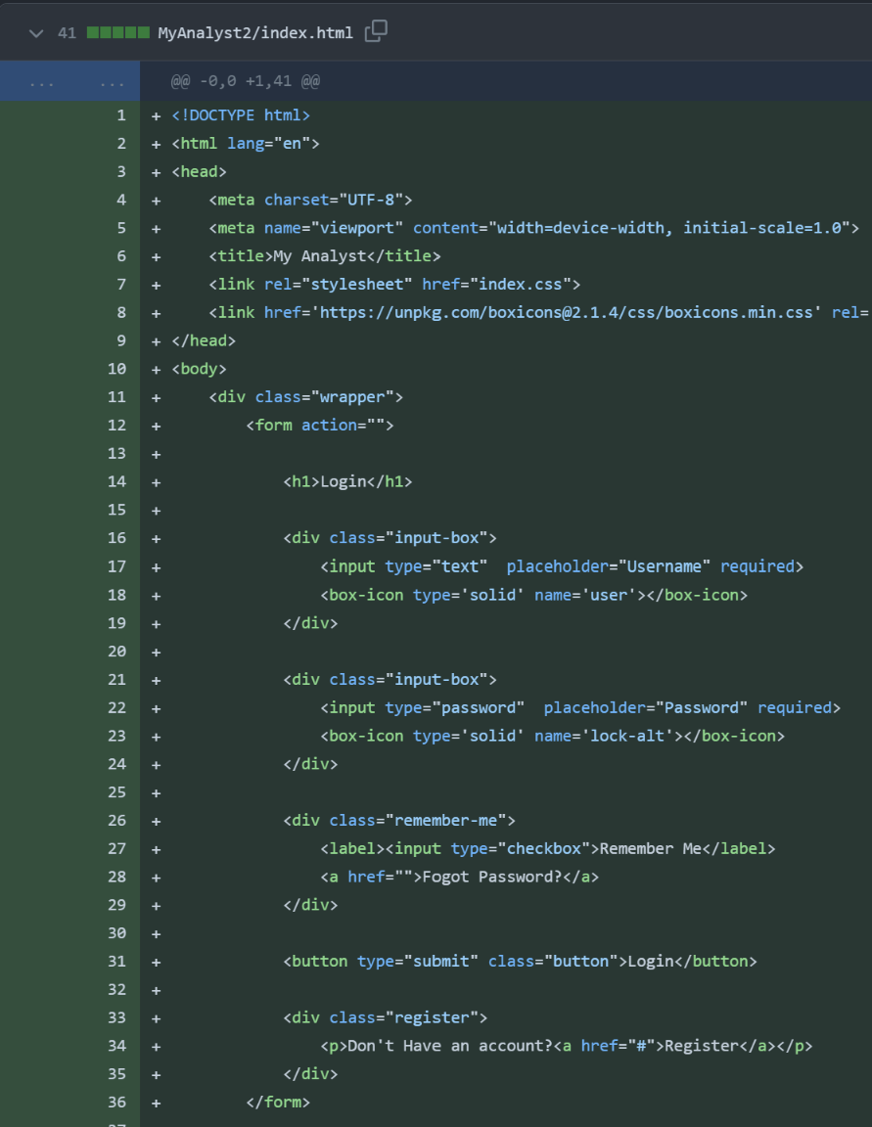Now using the standard stack I created the first design on my index page which is my login page.

The focus of the page is a form where users can enter their username and password and submit using a button.

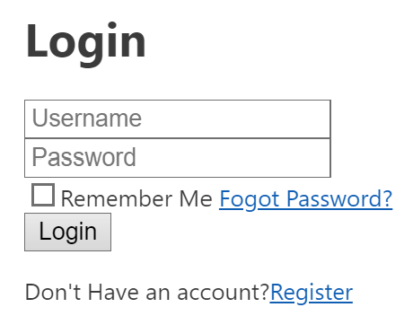Since this was the most important action of the page I focused on this first.

This currently looked like the form above.

I also uploaded a background image that I can add to the login page later on. Mountains seemed appropriate since they reflect climbing.

The blue and green palette also reflected the colours I wanted to use throughout my website.

## External Style Sheets:

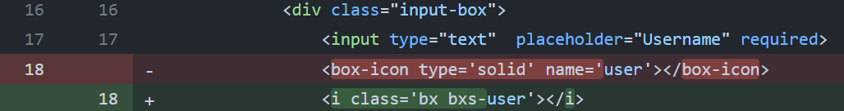I decided to use an external style sheet that would allow me to use icons I wanted to use for the username and password input boxes. The external style sheet allows icons to act as text instead of images. This makes aligning the icons easier and it is repeatable throughout the website where icons are used.

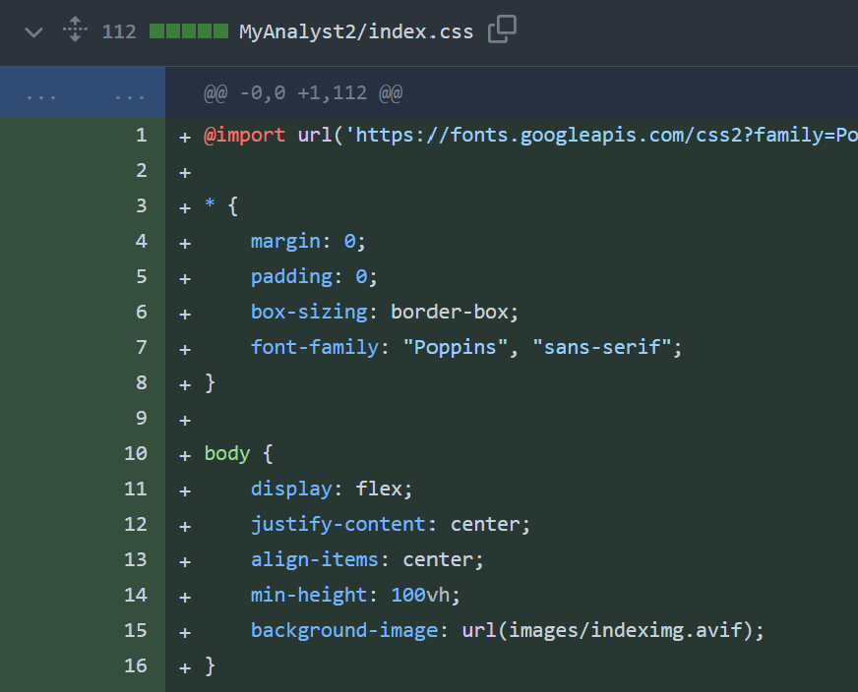I added basic CSS for the login page now, this included making the background image visible.

Now that all the items on the page are in the correct location I can begin getting the links and buttons to function correctly

## Switching between Login and Signup:

When users arrive at the website they are brought to the index page which is my login page. Users that don’t already have an account will need to create one.

My first method of switching to the signup process was to have the form required for signing up hidden initially and when clicking the signup button on the login page the login forms will be hidden and the signup form becomes visible.

I attempted to do this by giving the login and signup forms IDs in html and then when the button is clicked it will call a JavaScript function that will hide the one currently visible and show the one currently hidden.

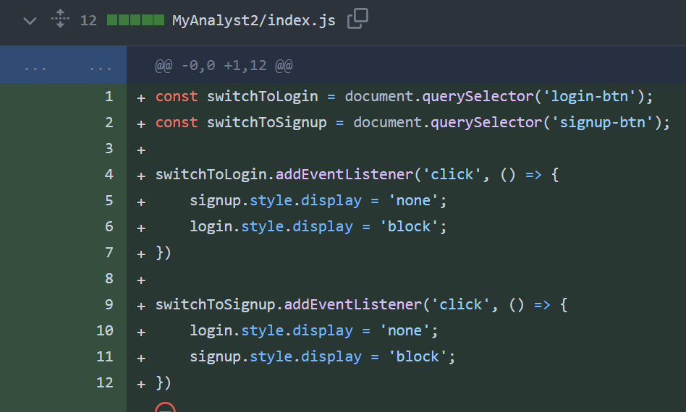To do this I had to change my hyperlink tag in html to a button tag as show above, this is because hyperlink tasgs cannot be used to call javascript functions.

The JS used is on the left, each button is made a constant and given an event listener which looks for a button click. Upon the click the JS will apply either a hidden style or block style to the form which should mean the forms can swap place without having to reload the site. This would make the user experience smoother especially for users with slower internet since once the webpage is loaded they will be able to login or signup without having to load another page.

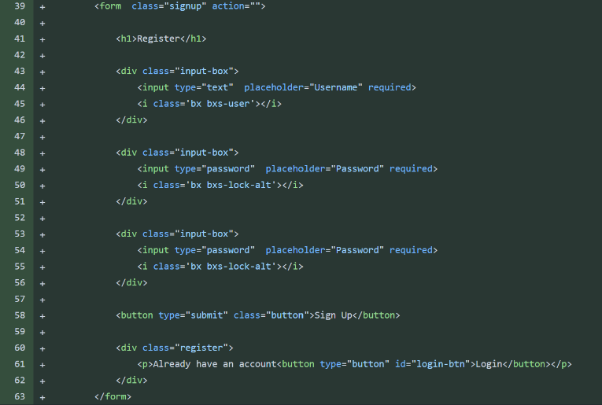On the left is the form for the user to signup, this is on the same html file a the login form currently.

After experimenting with this method and trying to get it to work I decided the easier option was to make the signup form on a different page that the signup button can redirect the user too.

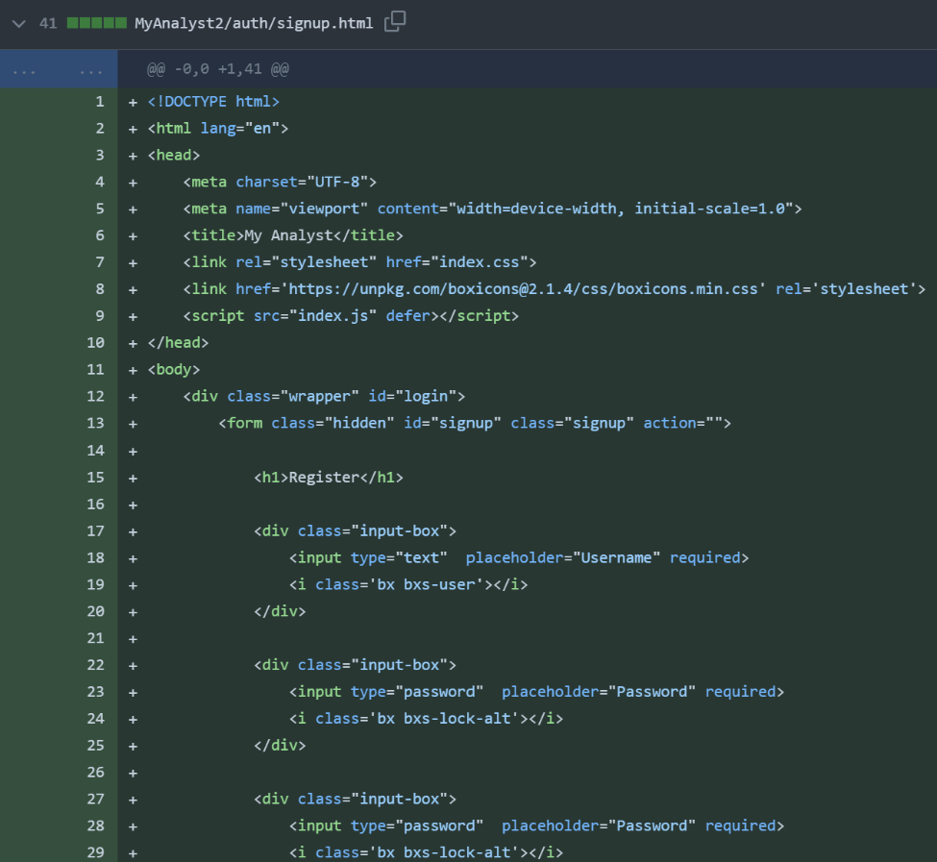The first approach didn’t work since when hiding elements in htm using CSS they still interact with other elements on the page. For this reason when hiding the login form it still caused the signup form to be pushed off the page.

On the keft is the new signup html page which is linked to on the index page via a hyperlink.

The main difference between the signup and login page visually is that the signup page has an extra input box where the user confims their password.

Each page also deals with the inputted data differently.

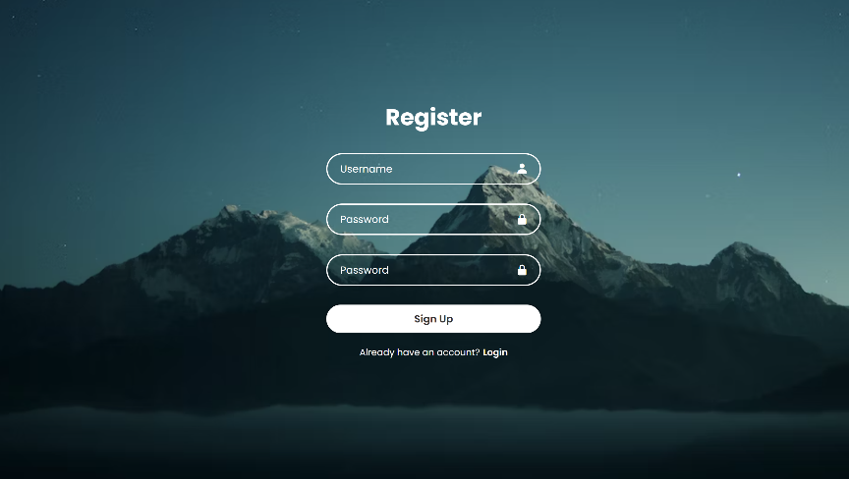The Styling for both pages is now also complete. On the login page the user can click on the register link that is Bold as to be obvious it is a link. A simular solution is found on the signup page also.

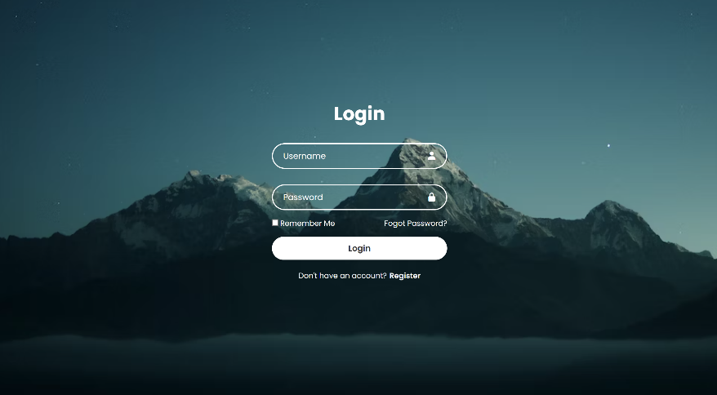

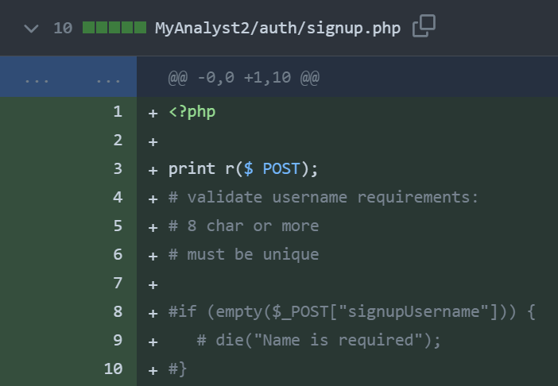I created a php file that can store all the functions and methods that will be used to handle the data submitted in the forms. To test the file is being called I got the php to print the post sent from the form. The form is setup with a method of post and the action is the php file.

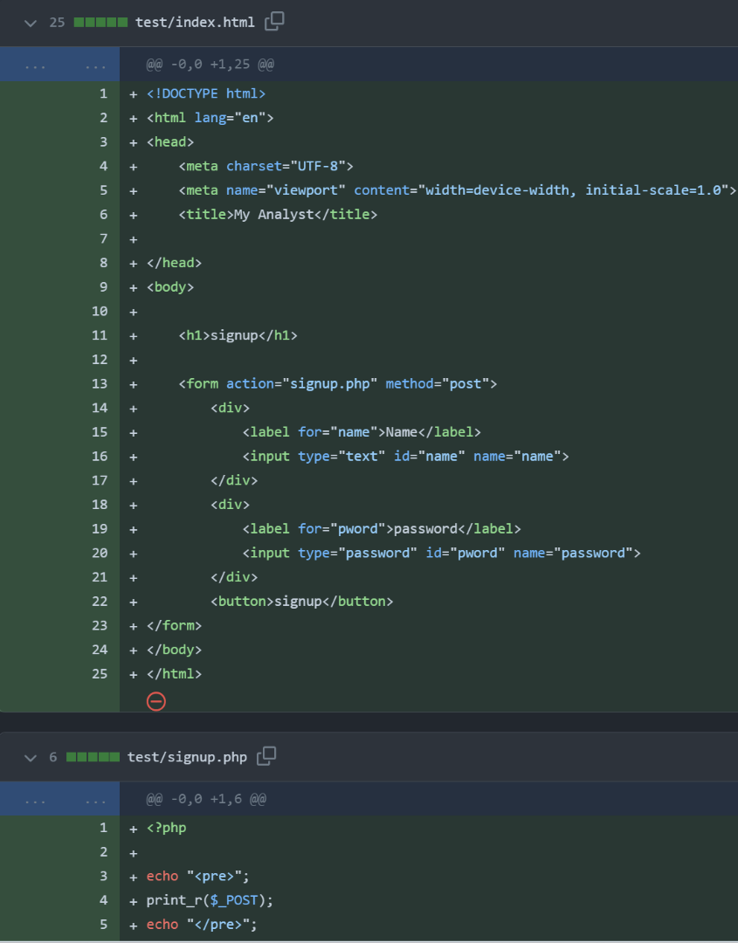Using comments I also structured out the validation steps I would need to add later on to validate the users inputted data. This would also require that I remove the built in html form validate method by adding the novalidate tag inside the form tag.

Since I couldn’t get the form to post correctly to the php file I created another similar html file with no additional styling or functions to test that my method should be working.

Currently the php file is correctly called when the form is submitted but instead of running the php code the contents of the php file are printed at face value to the webpage.

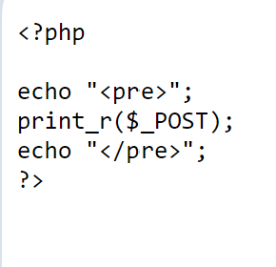I tested this got the same outcome.

On the left is the outcome of the test. Printing the contents of the php file.

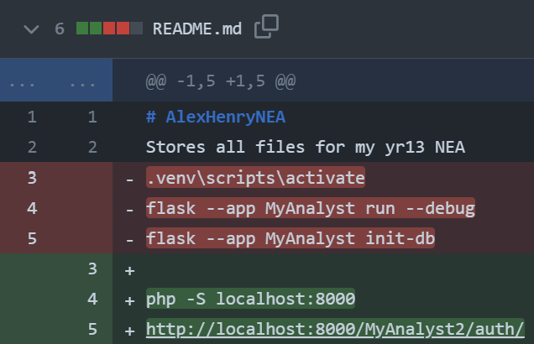

I realised my problem was that without running a server to host the webpage php isnt run. This is because php is a server side process so having a purley client side method means the php is no handed correctly.

To fix this I ran a php server asfter installing php to my machine. I added these commands to my ReadMe file. I also removed the flask commands as I am nolonger using flask.

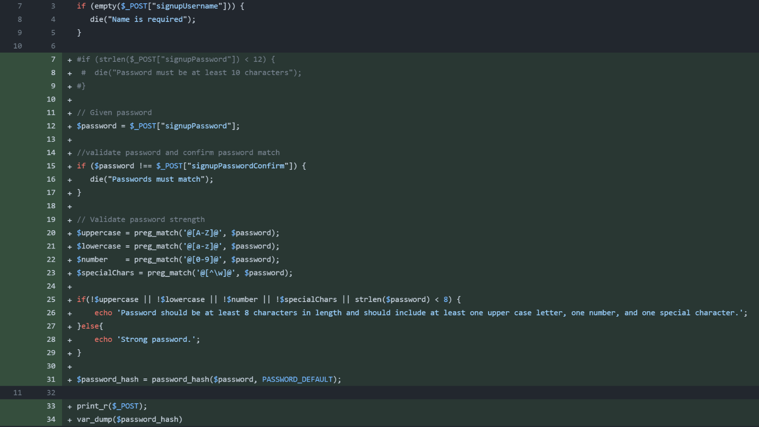No that my php is working I deleted the test file and continues coding the data handling for the signup page. When the data is submitted I run a series of checks to confirm it meets the requirments I have set. The first check is that the user didn’t submit an empty form or only half the form. If this is the case the php will return a message informing the user and stop running until its called again.

The second check is to confirm the password the user wants to use is strong enough. After letting the inputted password be a variable it is checked by an if statement that it meets all the requirments ( contains a capital, lowercase, number and special character. Must also be 8 or more characters )

After this is checked the password is hashed using phps built in hash algorithm. This is then stored in a variable to be used later.

To confirm this process worked I returned the post data and the hashed password after the php has been executed.

## XAMPP:

I realized that the solution I had for running my webpage server was not the best solution. The current method was hard to integrate with a database and also required manually running upon every change to the code.

I decided to use a popular webserver host XAMPP. This uses a Apache webserver to host the webpage on a localhost domain. This is updated live which makes debugging easier and

general coding easier. XAMPP also provides a MYSQL server which can be managed via PHPMyAdmin.

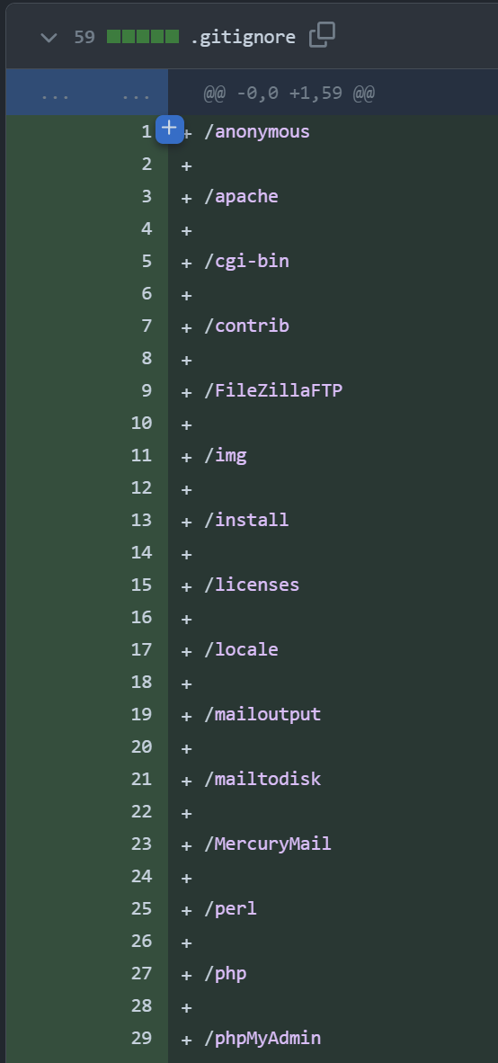I setup XAMPP to run Apache and MYSQL upon startup so I don’t have to worry about starting my server every time I boot my computer.

Due to XAMPP having a large folder structure I created a .gitignore file that would tell my git pushes to ignore certain files. I also created a separate repository that would store the database files.

## Database:

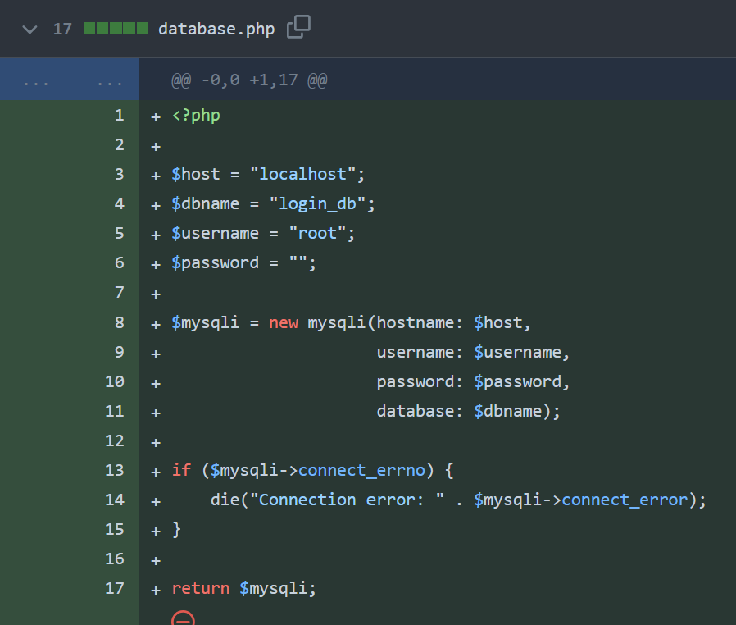I created a separate PHP file for connecting to the database, by having it in a separate file I can include it in and future files that will need a database connection. This will reduce the need for repeating code.

I decided to use a OOP approach for the connection since error the library of commands for dealing with a database with OOP is simpler than with a procedural approach.

When the class tries to create a new object of the connection if the connection has an error it should print the error and stop executing the php.

However I found that if there is an error connecting to the database the default error is returned rather than the correct error number and message from my code.

After some research I found that this is due to the recent php version changes, in the update engine warning are now fatal. This means when there is a error creating the new object the code will experience a fatal error and not run my own error handling method.

The first solution I found for this would be to modify the error handling in PHP 8 manually using the error_reporting();This function can change the severity of errors in php, the default will make many errors fatal but by setting error_reporting(0); Errors will now no longer be reported atall. However this is a bad solution since errors are an important as it helps you understand an fix the problems quicker. Without error reporting many errors may go unnoticed and/or will take longer to fix or find where code is causing errors.

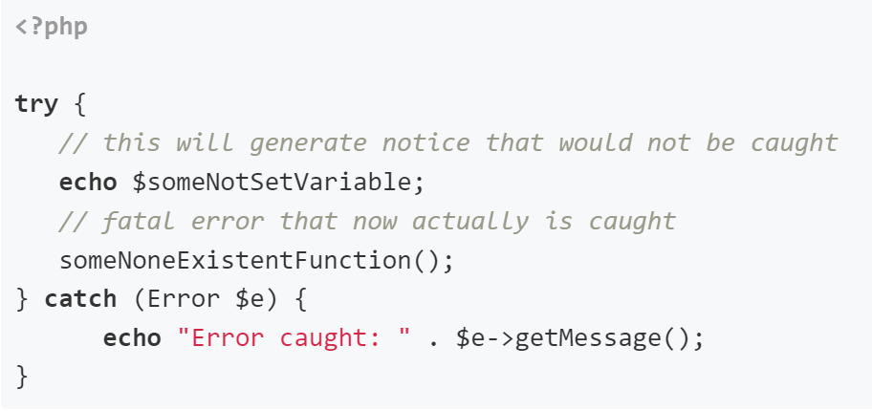The second solution is to use try and catch statements. This method it prefered since it will still produce error reports but in instances where errors need to be collected manually like here they can ignore the fatal error and catch exceptions.

I used this solution in my database php file to catch connection errors.

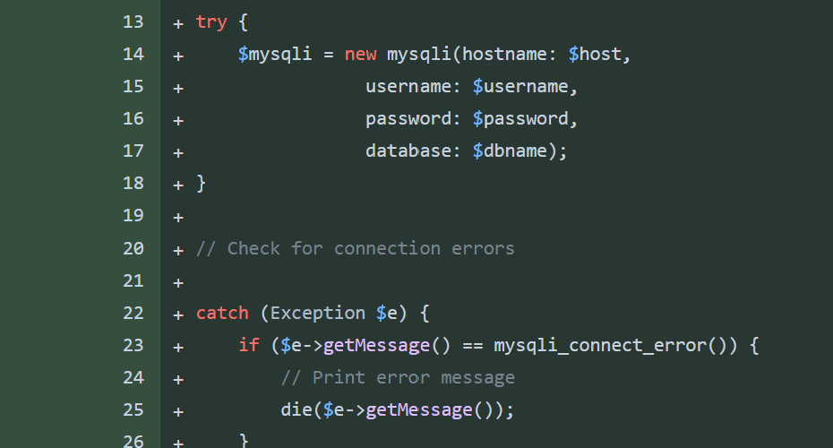This method will catch exceptions $e and get the message from the mysli error. This error will return more detail than the defualt error reporting will and can help me fix issues quicker.

I used a die statementwhen outputting the error as I still want the error to stop the execution of php code.



Above is the error produced when using the original code. This prints an error that is hard to understand and contains lots of extra useless information.

This is the error produced from the try catch method. This is much easier to undertand since there is no extra useless infmation. From this error, it is quick and easy to undertand that the password used to connect to the database is incorrect.

## The User_Table:

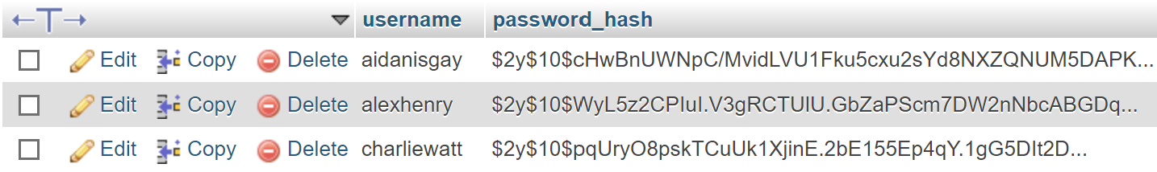

Above is the table used for storing users hashed password along with their usernames. In this table the username is a primary key.

## Signup:

Below is the php file for signing up, when user submut data in the signup form it is posted to here. At this point the username and password have already been verified to check they meet the requirments.

The new code in green now connects to the databse and will store the data. Line 33 requires the database.php file which contains the methods for connecting to the database as show above.

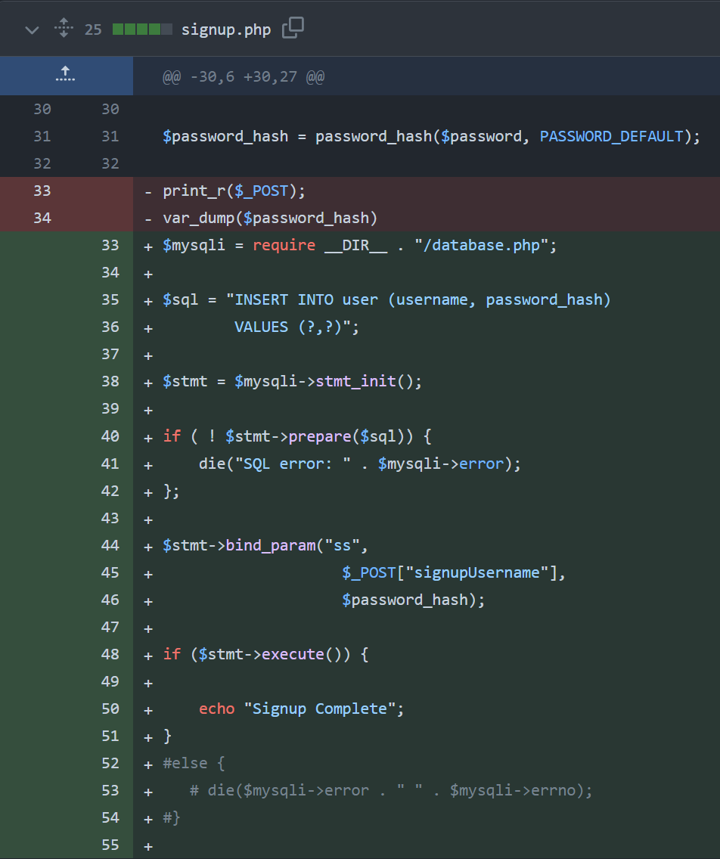Line 35 is the actual SQL query that will be run later on in the database. This statement currently has ‘?’ place holders instead of actual values. The actual values will be passed through to replace there holders when its nessicary. This protects against SQL injection attacks making the signup process more secure.

Line 40 prepares the sql statement to be executed and if this process doesn’t work then it will return the error. Errors in sql mostly occur from incorrect syntax.

Line 44 binds the parameters to the ‘?’ placeholders in the sql statement. We bind the posted username and the hashed password.

Line 48 will now execute the sql command and the users data will be stored in the databse above. If this process is sucsessful the user will be given a signup complete message.

After I confirmed this was working and added the first users to the database I needed a method of checking that a username isnt already taken. The two methods of doing this are to either do a try catch statement when executing the query to store the username and password in the database. If the username is already taken the execute will return a error since the username is the primary key in the table. There can only be 1 of any primary key in a table.

When the catch statement catches the exception I can read and compare this error so that if it is the error corresponding to the username being taken already I can return a message to the user informing them it is taken. If the exception is not for the username being taken I can return the error mesasge as normal.

The other approach which I decided to use was to read the contents of the database and check if the username is already in the database. This wasmy prefered method since deliberatley using errors in php is not good practice.

The best method I found for doing this is using the sql statement $check show below. This statement will read the whole database where the username matches the inputed one. A 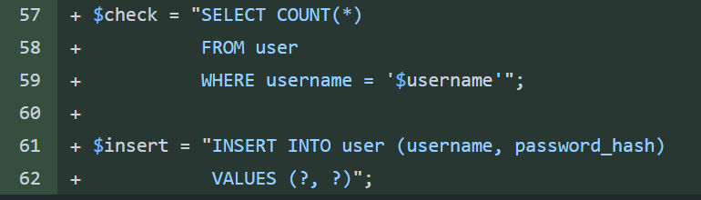count method is used aswell so that the statement will return the number of times the same username pops up.

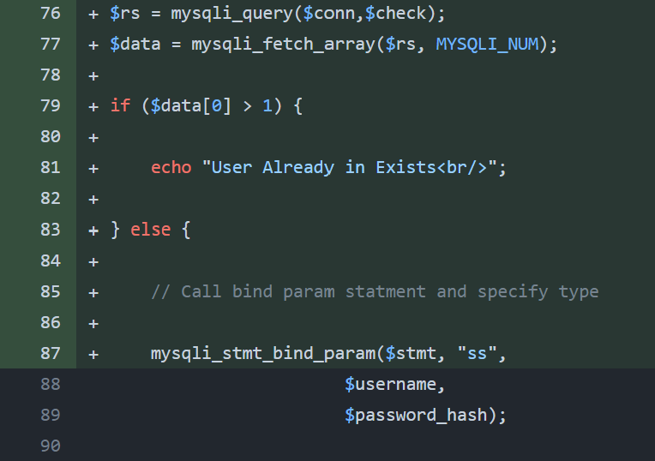Line 76 will run the query $check and store the returned database array in a variable called $rs. Since the number of occurances cannot be compared when its stored in an array on line 77 I use the mysqli_fetch_array method which will convert the database array into a format php can understand.

This array storing the interger representing the number of times the username appears In the database is stored in the variable $data. This value theoretically should only ever be 1 or 0 since the same username should not occur more than once in the database.

Using an if statement I check if the array $data contains a value greater than one in its first index. Im not sure why but when using this SQL query when no matching usrnames are found the count method will still return one. When 1 matching username if found the query will return 2. For this reason I check if the index is greater than 1. If this is true the username is taken and a message is sent to the user.

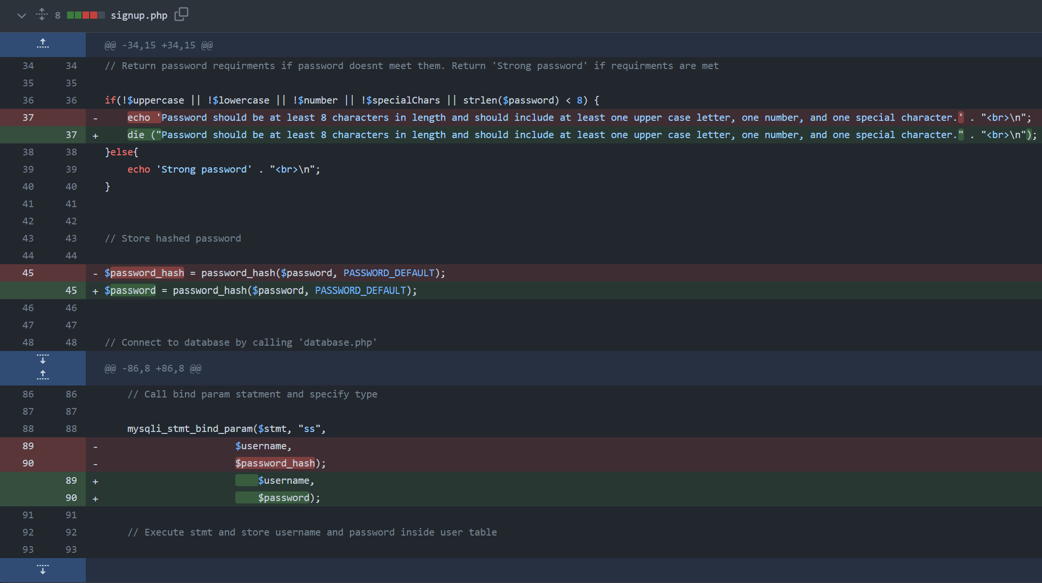If the username is not taken the program continues executing and the parameters are bound to the storing sql statement like normal.

I also went back through the signup.php file and fixed a few logic and security issues.

The first was that the code would continue running even after the algorithm has found the password doesn’t meet the verification standards. This is fixed by running a die command when returning the issue with the password to the user. This will cause the php to stop executing once the message has been outputed.

The second error was a security error since the password was being stored in a variable then when hashed this was stored in a new variable. This ment the password was stored in a variable that was not needed anymore. I fixed this by storeing the hashed password in the same variable the original password was stored. This mean the password is overwritten whn the hash is stored.

The last error was a logic/type error caused by changing the hashed password variable name in the fix above. To fix this I changed all the instances of using the password_hash variable to be using the password variable.

## Login:

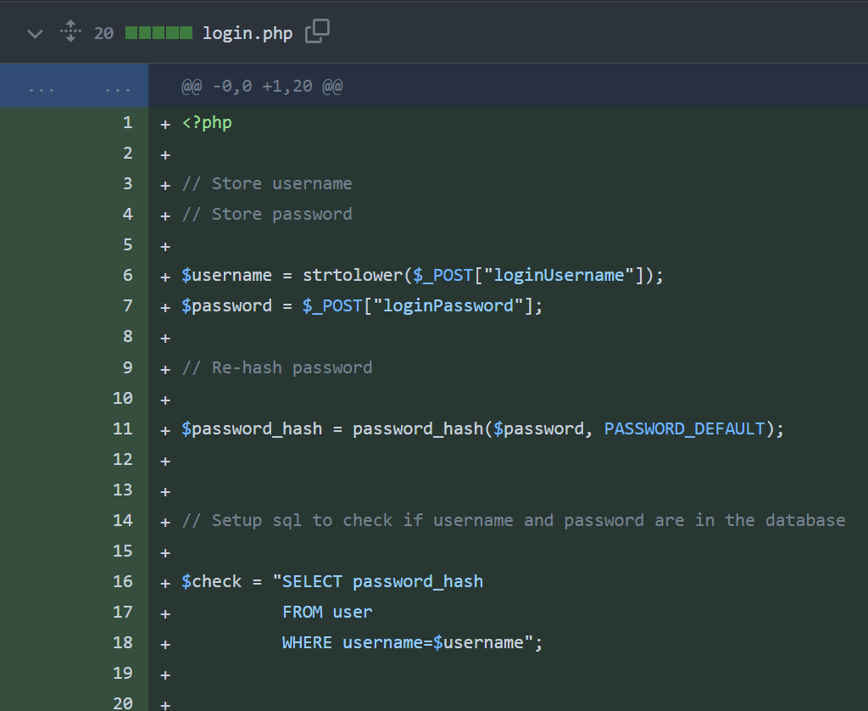I started the baseline for the login.php file similar to the signup.php file by storing the posted username and password as variables then hashing the password.

I then created the $check SQL query which should select any passwords from the database where the username matches the posted one. There should only ever be one password returned since the username is a primary key.

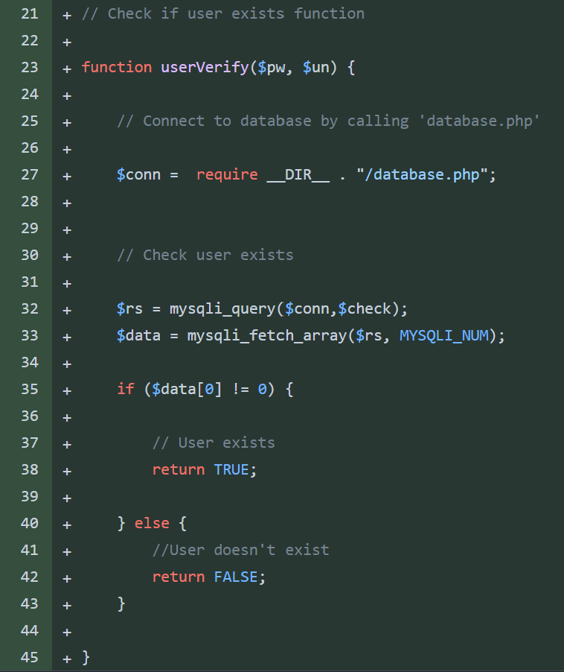I also created a function to run this SQL. The function will require the database connection then run the SQL query. This will return an array and will be stored in the $rs variable to make the array understandable to php the mysqli_fetch_array method is used again.

To check if the user exists I check if the $data variable is 0 or not. If the array contains the integer 0 the user doesn’t exist since their username

cannot be found in the database. If the username is found the user exists but the password will still need to verified.

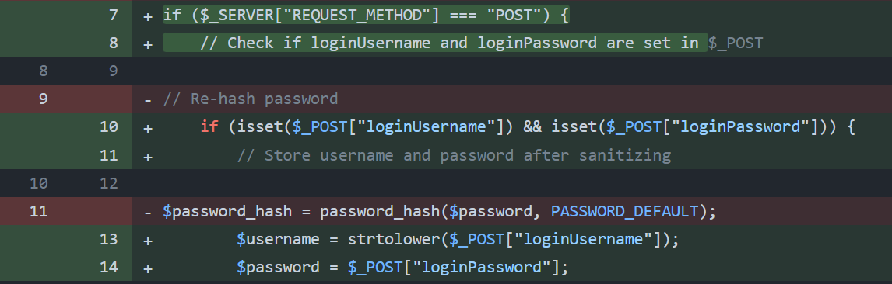I also added some protection to my code for accidental submissions and to avoid code running for no reason. When the PHP file is called it will first check the server method is post. This means the program will only continue if the server has received a post from the form.

The second layer of protection is to check the username and password have both received data in the post. The code will only continue if there is data in the post. If this step wasn’t included the username and/or password could be set to nothing which would cause errors later on.

I also added this layer of protection to the signup page and will use it for any further forms that have posted data.

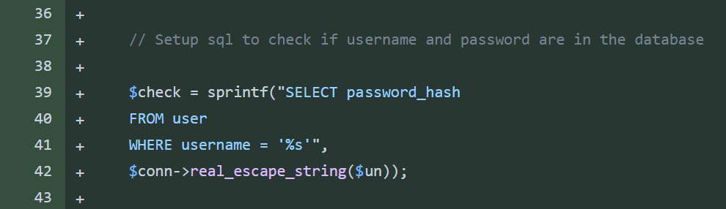The current method I was using to check the username was venerable to SQL injection so I used a sprintf function.

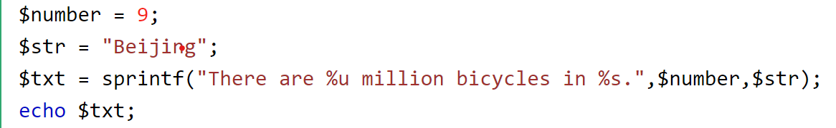The sprintf function is a way to input data securely into strings of data. By using % symbols followed by different letters to show the location and data type that will be submitted. Different letters are used to represent different datatypes. E.g. %s is a string and %b for a binary number. The data that will be used is written after the string.

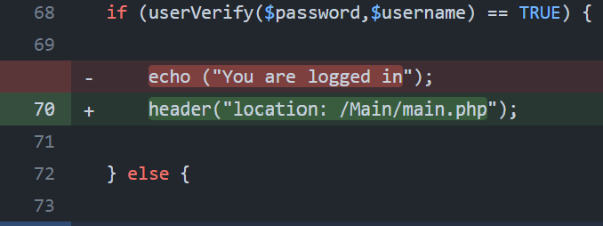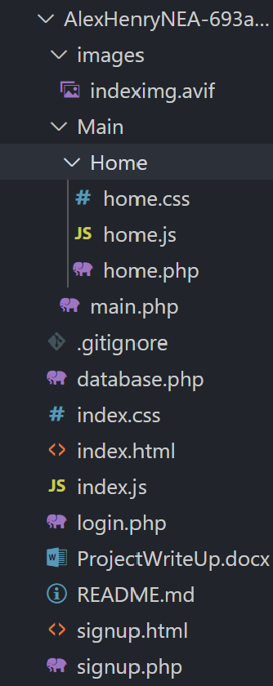The real_escape_string() function escapes special characters in a string for use in an SQL query, taking into account the current character set of the connection.

I also changed the response of logging in to redirect the user to the login page instead of outputting a message.

My current folder structure looks like this on the left. I created a black page that will eventually be a question page. The login page currently redirects the user to here if there is a successful login.

## Question Pages:

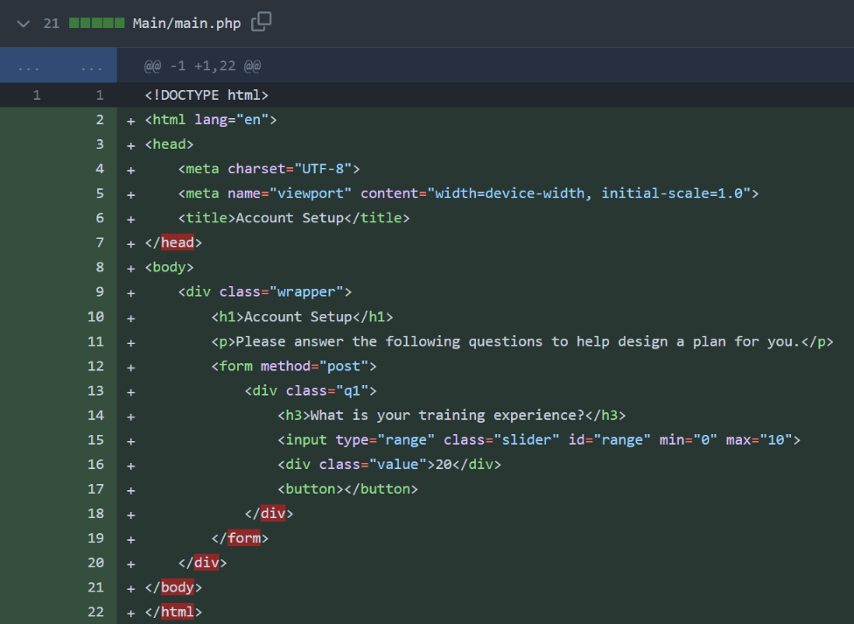I added the backbone for the question page. I decided to write my html code inside the php file instead of having a separate html file.

I decided to use a range slider for the input for answering a question. This measn I can dictate the values the user can input. This means I will need to do less verification of the posted data when the form is submitted.

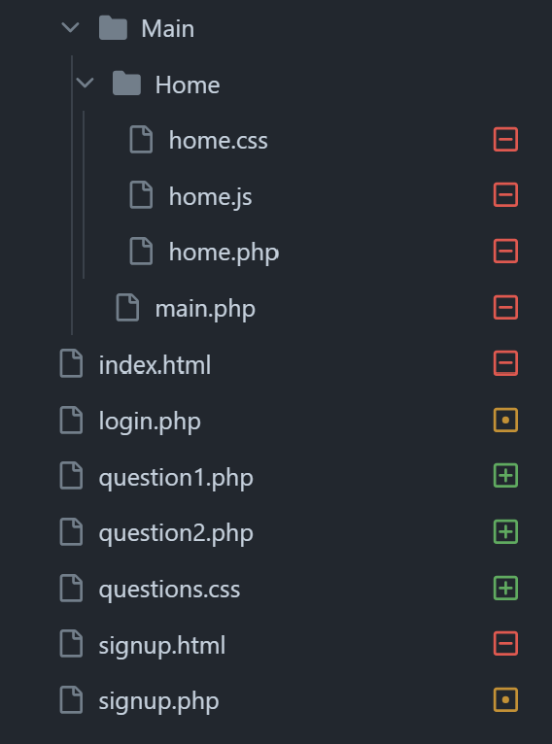After using the same file for html and php I realised it was a lot easier to track the functions and prcesses of the website so idecided to change all my html files to php. This ment I could move my php form management code into the same file as the html. The only downside I found of doing this was that autocompletion of code didn’t work as effectivley for html anymore.

At this point I also created a generic css file for styling all the question pages this can be linked in the head of the html on att the question pages.

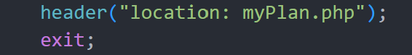I also decided to create a functions PHP file that can store a lot of the subprograms and functions that I call throughout the website. This improves the readibilty of the page PHP files. I can include the functions.php file at the start of every page and then use the functions stored in the file easily. If I choose descriptive names for the funtions it should be obvious what each subprogram is doing without needing to read the actual function.

I also went through my code and added exit commands after every header tag this ensures the code after the header is not ran.

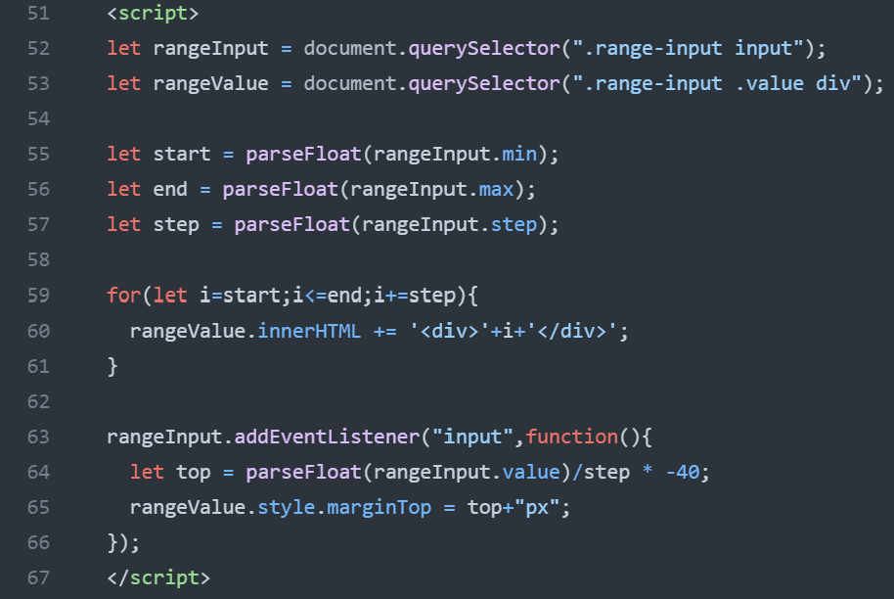 On each question page I added JavaScript that would model the range slider to display the value currently selected. (explained below). I also used css to make this look nicer.

Left – Range slider set to value of 7, Right – Range slider set to value of 0 (default).

The JavaScript starts by selecting the range input element and the div element where the range values will be displayed using the querySelector function. Then, it extracts the minimum, maximum, and step attributes of the range input and converts them to floating point numbers.

Next, a for loop generates the range values between the minimum and maximum values with the specified step size. Each value is appended as a div element to the container for displaying range values.

Then, an event listener is attached to the range input element to respond to changes in its value. When the input value changes (i.e., when the slider is moved), the event listener function calculates the top margin of the range value container based on the current input value. This margin adjustment causes the displayed range values to move up or down within the container, providing visual feedback to the user as they interact with the slider.

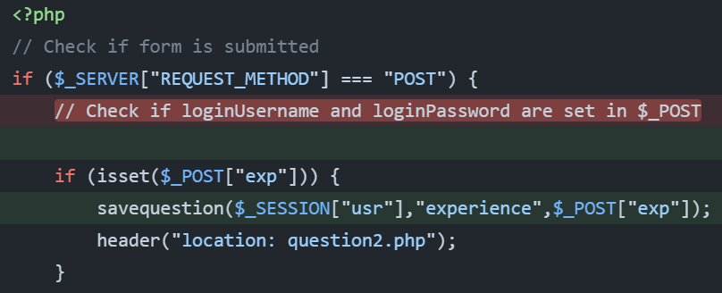When the form is submitted the code on the left will run since the server request method will now be post. After checking the variable that the question is about is set ( in this case the users experience) the code will call the savequestion function. This function is stored in the functions.php file since it is called by all the question pages. After the function has ran the user will be redirected to the next question. If it’s the last question they will be relocated to the myPlan page.

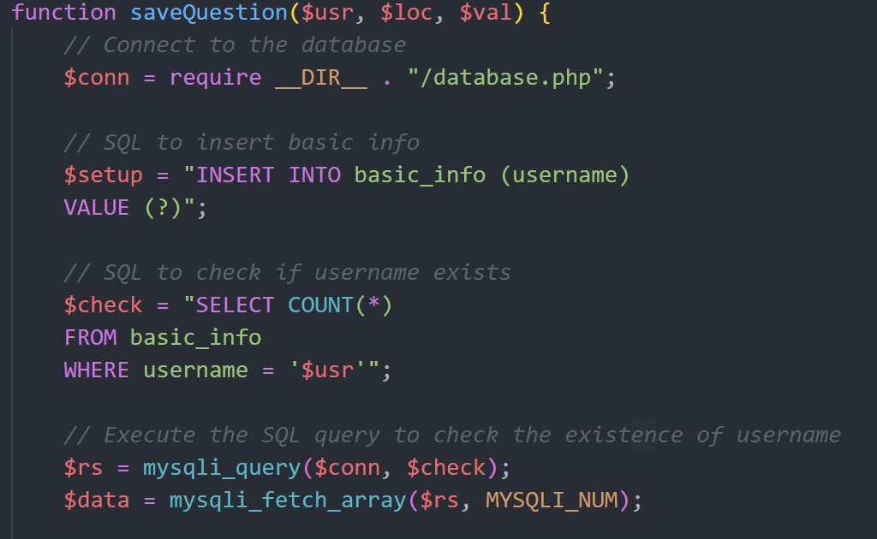The function commences by establishing a connection to the database using a separate PHP file called database.php. This connection is established via the require __DIR__ . "/database.php"; statement.

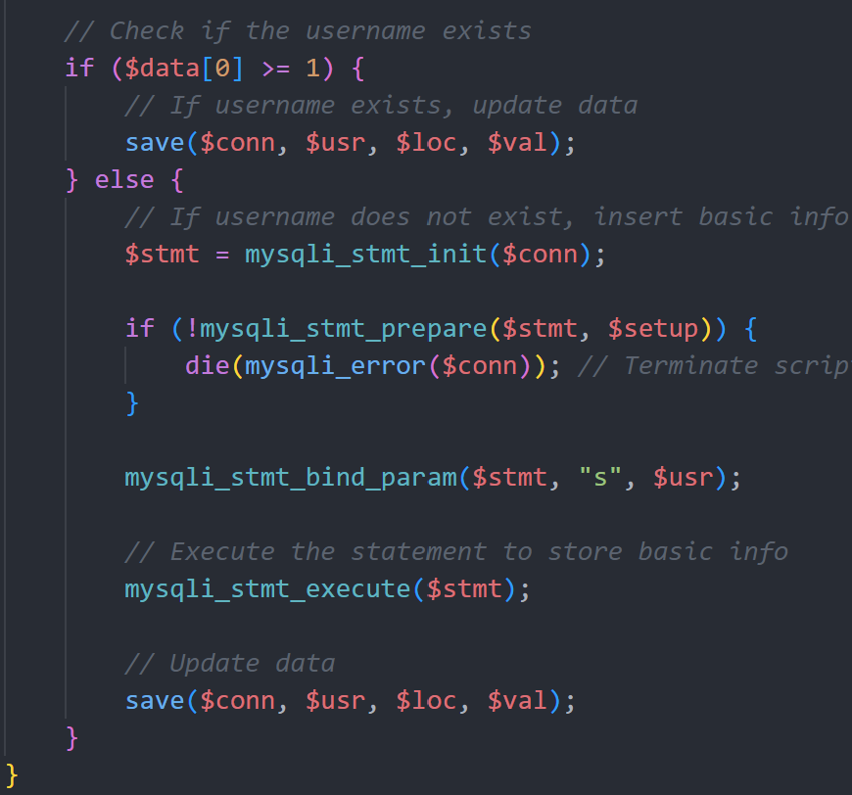Then two SQL querys are setup as strings that will be needed later. The first query $setup will insert a value into the basic_info table. The second query $check which has been used before if used to check for the existance of the username (primary key) in the table.

If the username is already found in the table the save function is called.

If the username isnt already setup in the datbase the first query is used to store the username in the database.

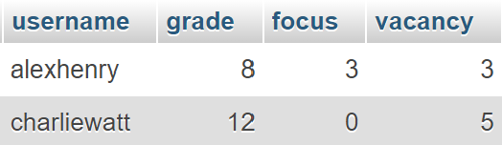This is nessicary since all the question pages will call this function but the username only needs to be stored once. The Table is shown below:

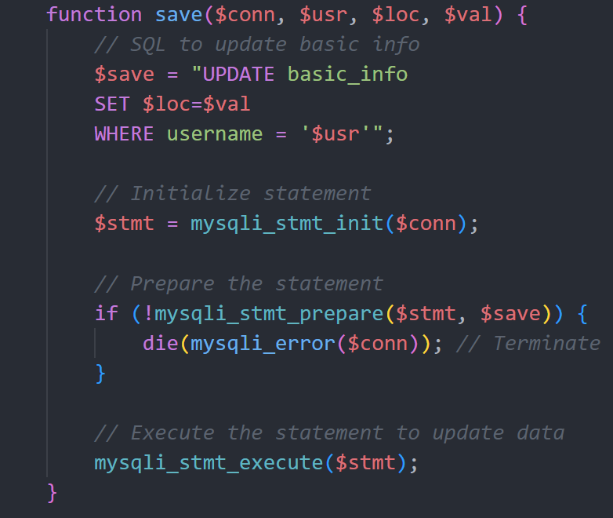The save function takes the connection to the database, the username, the location (coloumb), and the interger value to be stored as parameters.

First the SQL query needed to save the value is setup as a string and saved to a varible $save. The query will update the basic_info table and set the passed location to be the passed value. This is set where the username is in the table.

Next the $stmt is setup using the mysqli_stmt_init() function that initializes a statement and returns an object suitable for mysqli_stmt_prepare().

Then the mysqli_stmt_prepare() function finishes preparing the statement. If there is an error at this stage the if statement will catch it and the php will die returning the error.

Finally the query is executed and the value will be stored in the appropriate location in the database.

## Sessions:

I needed a way to track users being logged in, this is important so that they don’t access pages without having an account since the pages wont work.

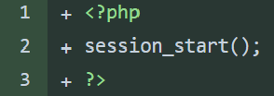The two ways to do this are SESSIONS and COOKIES in php. The main difference is that session is server side and cookies are client side. I decided to use sessions as they suited my use case better. On every page the session_start() command needs to be called. This will start or resume a session. This allows session variables to be kept throughout the session.

The session variable I use to check the status of a session is the ‘usr’ variable. When a user logs in their ‘usr’ session variable will be set to their username. This will be useful throughout the program to access the database since the primary key is the username.

When users wish to logout they can click a button, this will unset the session ’usr’ variable and redirect users to the login page.

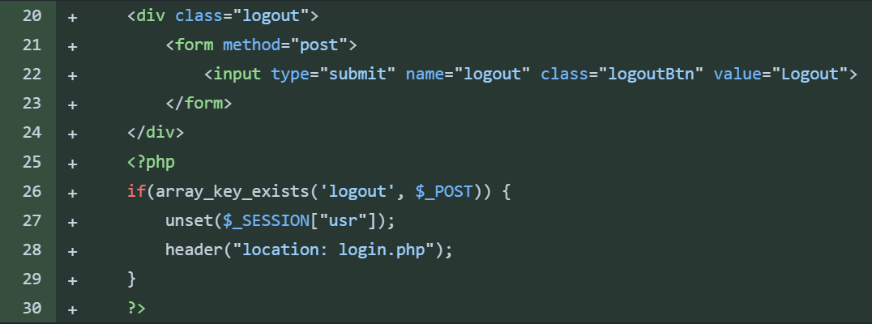On every page when a session is started I will check that the ‘usr’ variable is set. If it isnt then the user isnt logged in and they will be redirected to the login page.

On the question pages there is a dedicated logout button in the top right this will not need users to be redirected to the logout page. Instead the button is setup as a form and when the form is submitted php runs that performs the steps needed to logout.

## Login Bugfixes:

While testing the login process I found that the login process didn’t work. The current method (left) took the username and password as parameters and then searched the database for where the username was the same and the password was the same. However this didn’t work and even with the correct username and password the user would not be logged in.

This was because the hashing algorithm used before storing the users password used more variables to create the hash than just the password itself. This meant every generation of the hash using the algorithm would produce a different hash even when hashing the same password.

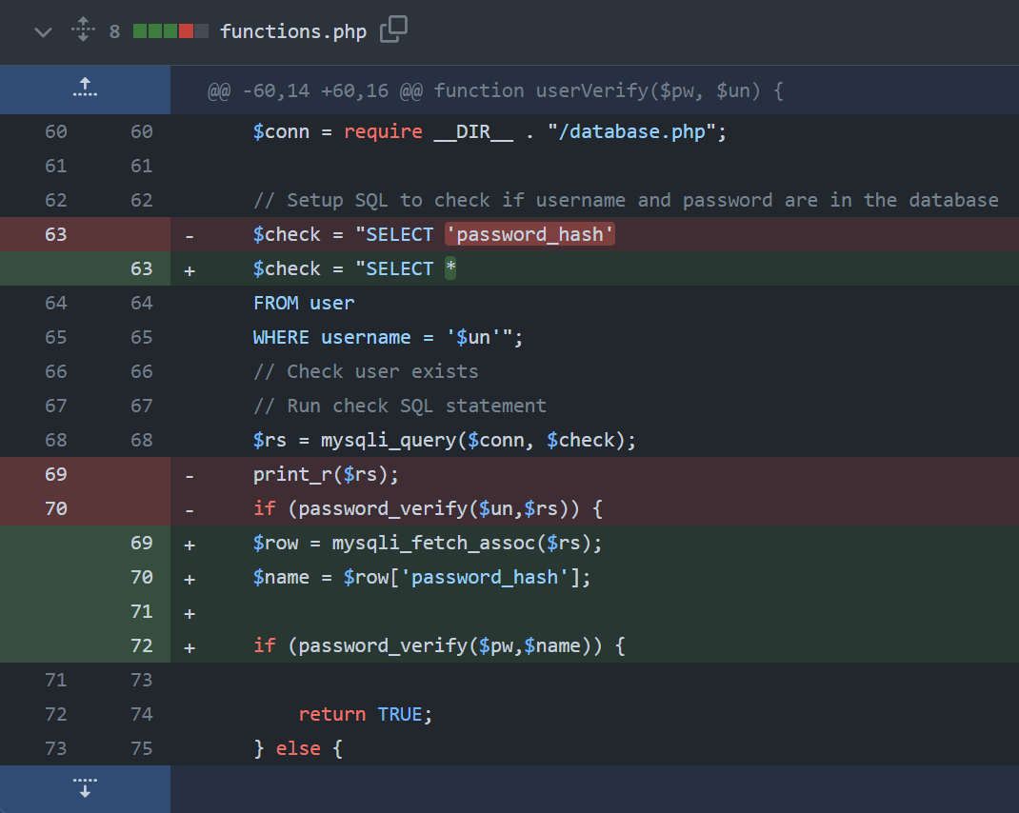This meant when searching the database for a matching password there would be no results since the hash is unique every time.

The solution (right) was to use a built in php function password_verify(). This function will take two hashed passwords and return true if they match and false if they do not.

So the fix was to read the hashed password from the database where the username matches and store this as a variable then use an if statement that would check if the function would return true or false. If the function returns true the username and password are correct and the user will be logged in.

I also added protection for if the user doesn’t input a username or a password with a simple if statement that will die if there isnt both inputs. 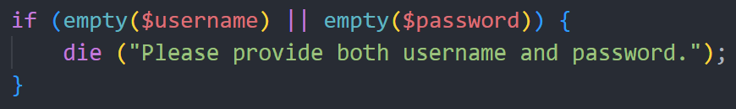

## My Plan Page:

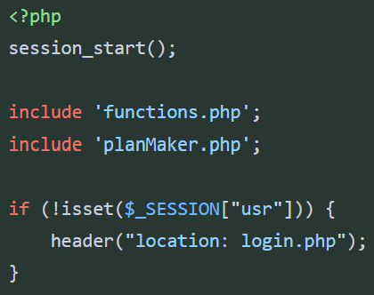I created a PHP page that will display the users training plan. This includes the normal head metadata and also the necessary php inclusions and commands at the start also.

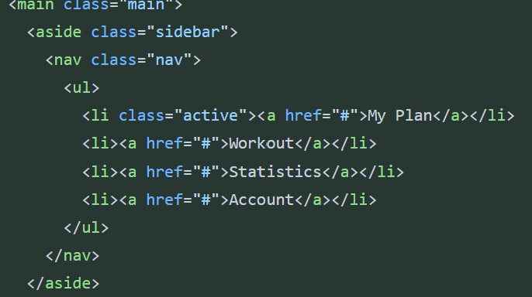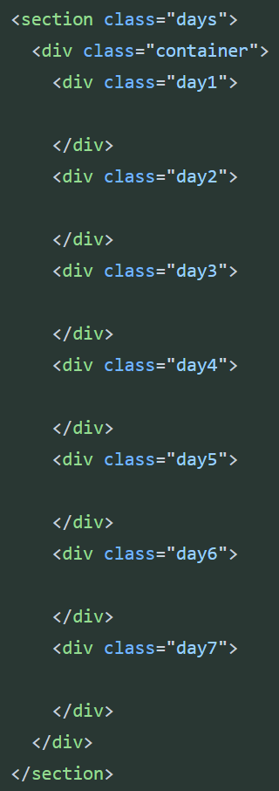On the right is the template for how the days in the plan will be layed out. This is in its own section. The other section shown below is for the sidebar.

The navigation sidebar is layout in an aside tag with a list inside each list element is a href link to the other pages.

## Plan Maker:

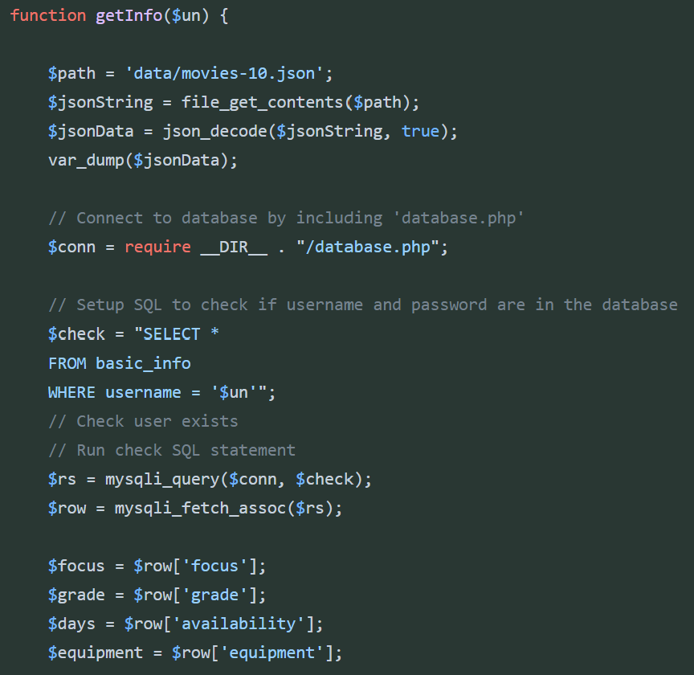I created a separate PHP file to store the algorithm to make the users plan this is because I predicted the algorithm will be long and it will made readability easier on the my plan page if the algorithm is stored in its own file.

I used a function to store the algorithm since this can be called at any point where its nessicary.

To allow the function to be ran in other files I included it in nessicary files such as the my plan page.

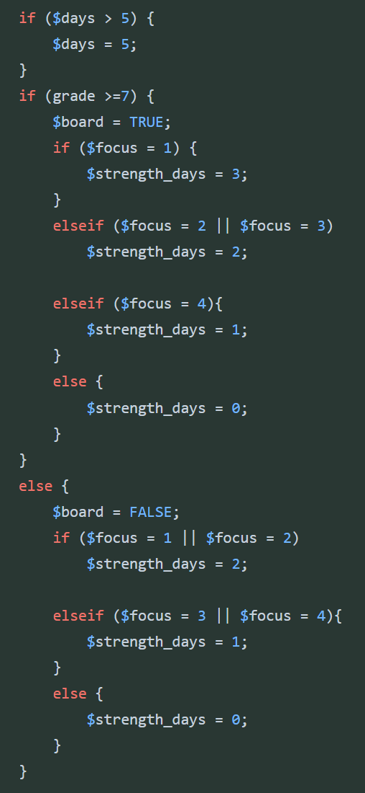The first step of the function is to get the execises from the json file they are stored in. They are stored in a json file therefore they must be decoded into a format that php can understand.

Firstly, I stored the path variable as a variable. I used a place holder since I havent made the json file yet. Then I read and save the contents of the file as a variable. Finally, I decode the data using the json_decode function. I’ve also included a var_dump funtion to return what we have decoded, this is purely for testing.

The second step of the function are to get all the users details needed to model the plan. These are stored in the database. Using a simular setup to previous I read the database where the username (which is stored in the session variables and will be passed in as a parameter) matches the databases primary key. Using this I can assign the users focus, grade and days values to variables. I also included the equipment variable which hasn’t been setup in the database yet.

The next step to was to use the data to create a plan. My first attempt as shown on the left was to use a series of if statements to setup new variables such as $strength_days. These variables would be used later to assign exercises to each day.

I realised this method was going to be highly inefficient and hard to understand so decided to try a new approach before finishing.

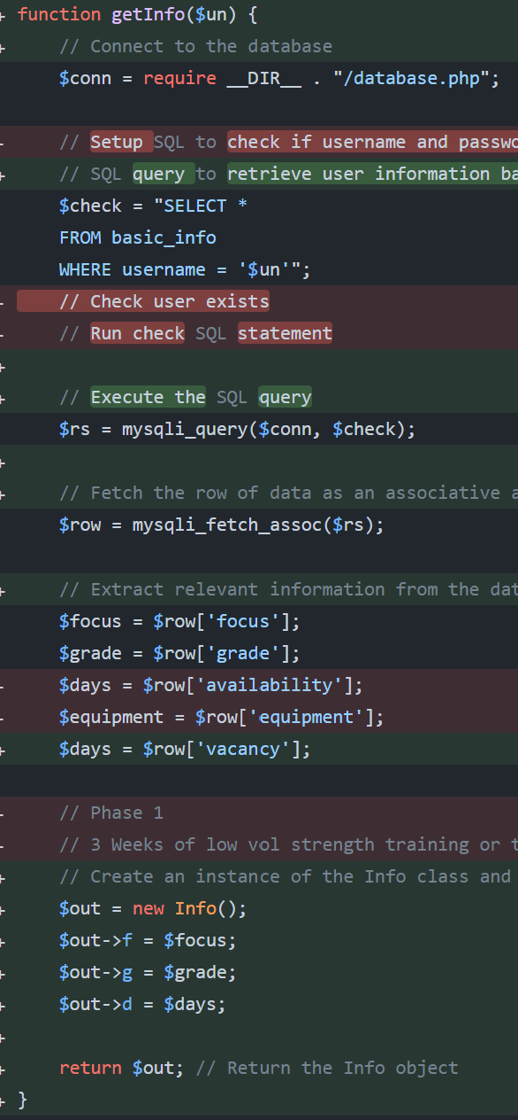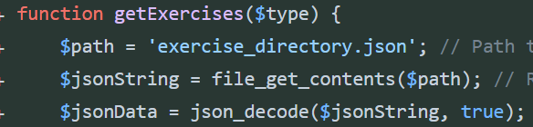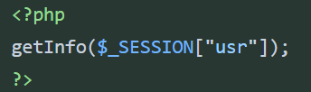I also removed the template I has made in the my plan page for displaying the users plan as I decided it would be easier to display it using php. It now look like the code on the left.

My second attempt was to use a procedural style approach and make functions that would be responsible for induvidual tasks. The first was to retrieve the exercises from the json file as before (left). However a new feature is that the function will return the exercises that are of the type specified in the parameter.

The next function was the original function which would return the users info. This is done via the same method as before. However since multiple values cannot be returned out of a php function I used a class to store the values as an object. Then I could save the values of the object to variables outside the function after.

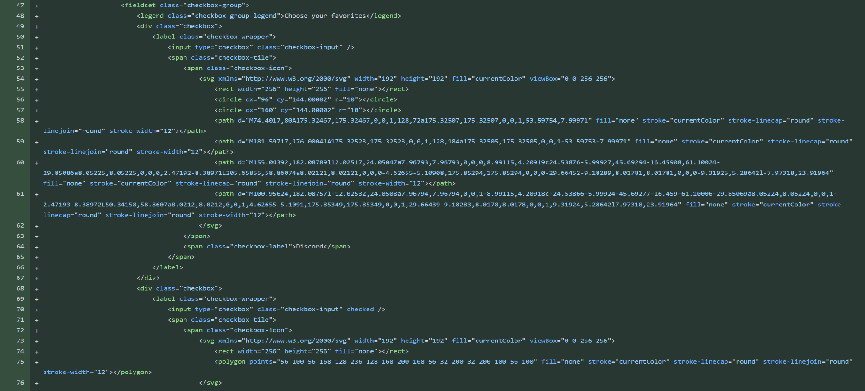At this point I also tried to create the 4th question page that would store what equipment the user has. I wanted to do this using checkboxes with online css styling. I tried this below but could not get the form to submit correctly. I also realised after talking to my stakeholder that this feature was not essential as Ben liked to manually add of change exercises himself when equipment wasn’t avaliable. After this I decided to stick with 3 questions for my algorithm.

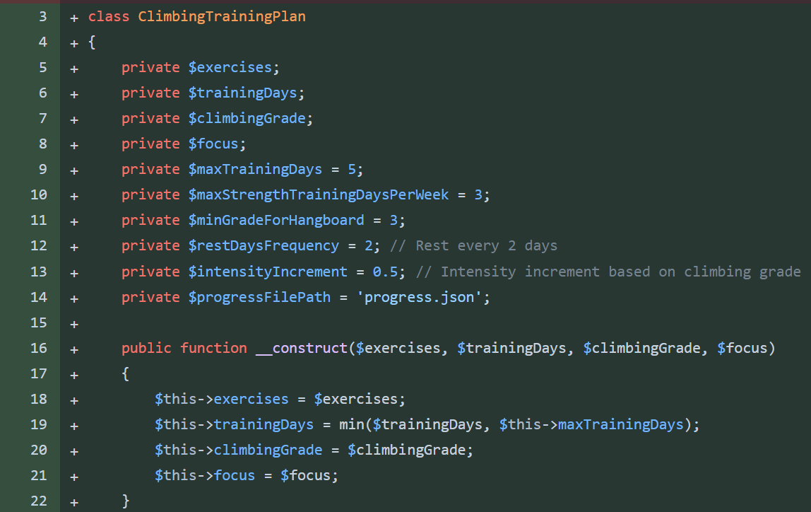With the plan algorithm I decided to switch to using a combination of OOP and procedural. This will encourage encapsulation aswell as make it possible to create multiple plans. This will help later on when the user will be able to interact with the plan and manually change aspects.

This is the start of the class used for creating the plan. All the variables are private. All important constants are also stored as variables to make understanding code easier.

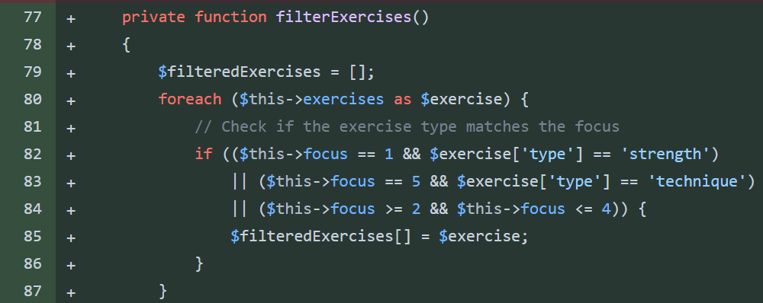The constructor method will take all the outside input needed for the plan and store then in variables.

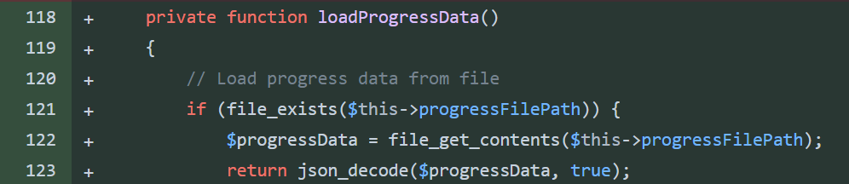The filterExercises function will return an array of exercises that are to the users focus. Eg a user focusing on strength will be given more strength exercises in their filtered array.

The loadProgressData will load the progress data from the progress file. This is a work I progress part and I’m not sure if it will be included in the final algorithm.

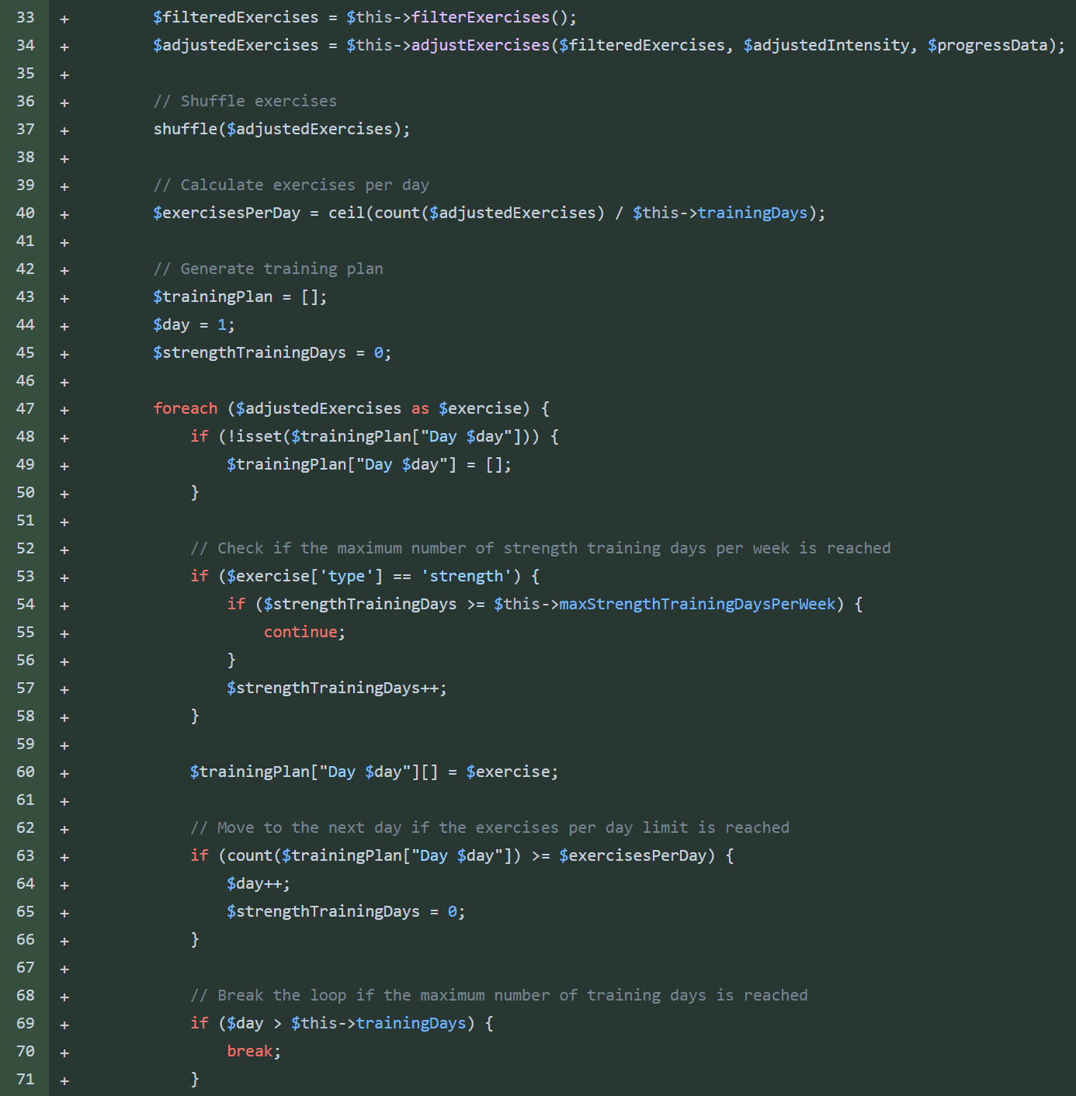This is the main bulk of the algorithm so far. The filtered exercises are received from the function. These will be sent through another function that will adjust the sets and weight needed for each exercise. Then the array is shuffled.

Line 40 ensures the exercises are spread evenly throughout the days of training.

Then the algorithm uses a foreach loop to append exercises to the training plan array. This is done day by day. When the number of exercises per day is reached the day is incremented. Inside the loop there is also a chek for the number of strength days in the whole plan. This cannot exceed the man number of strengthTrainingDays which was defined in at the start of the class.

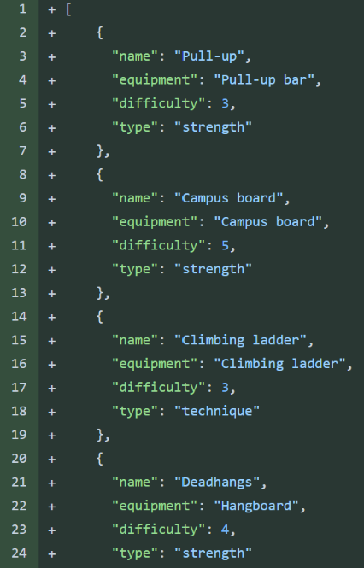I created the json file to store all of the exercises. Each exercises is given required equipemnt a difficuty and a type. The tye can either be strength or technique.

The first difficulty scale I used was a 1 to 5 scale where 5 is the hardest exercises. After experimenting with comverting the users climbing grade to a measurable difficulty I realised the scale was not precise enough and that using a different scale for difficulty of exercises to the performance of a climber was not nessicary.

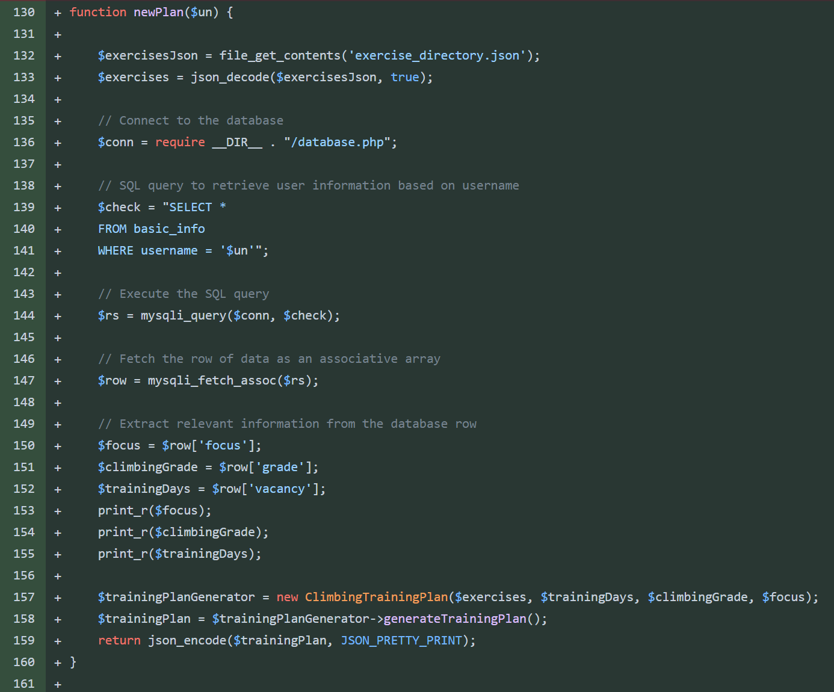I changed the difficulty scale to be based on the grade of the a climber. For example a exercise with a difficulty of 3 should only be given to climbers who climb at a grade 3 level or above.

I created a function that would call the class and return a new plan when called. This could be called from the my plan php page. This function also contained all of the code needed to get the data needed for the class.

The function gets the users focus, grade and avaliability from the database. It also reads the json file to get all the exercises in a format that php can model. These are passed into the constructor class then the object of the class is made.

I realsied my algorithm lacked depth and was missing many important elemnts for a complete training plan such as:

* Exercises only used once
* All training days one after another
* Users were either given a technique or strength only plan
* Simular exercises could be chosen one after another

To decided to try from the start again to fix these issues since adding this many new functions to the current code would make it very cluttered.

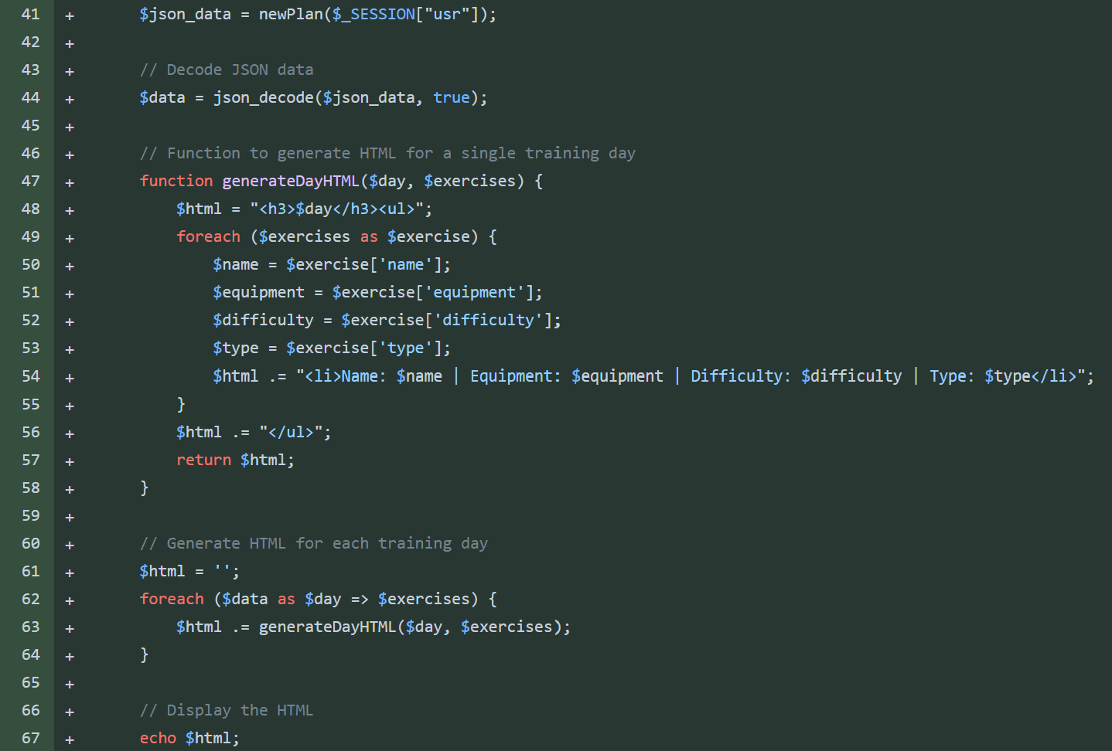I also added a display method for the plan to the my plan page.

When the newPlan function returns a json array of the plan it is first decoded and stored in a variable.

Then for each day I call a function that will print the day name followed by the exercises and its details. The function is called for each day in succession. The function returns html for the day of training and this is appended onto the end of the current html.

After all days have been gone through the html is echo’d and displayed on the page.

## Plan Maker Attempt 3:

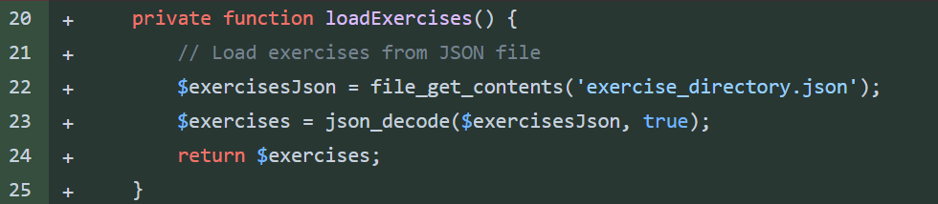The constructor on the new solution was simular but I fixed a logic error with the focus. The javascript I wrote for the range slider for the focus input starts at 0 and will not work when it starts fro 0. Therefore my focus range is actually 0 to 4. In my algorithm I use the values 1 to 5 so I increment the focus in the constructor.

Another change is that the exerises are not passed in when making the object. Instead a new function loadExercises() in the class will read the json file and return the exercise array.

The final change is that I am actually using the $maxTrainingDays variable before I was using the interger 5 instead of the variable setup already. This should make the logic easier to follow since before it wasn’t obvious why we were limitng the avaliability to 5.

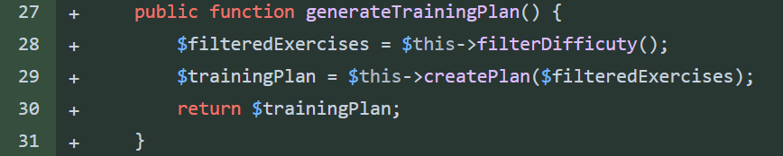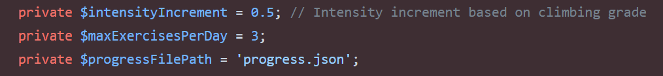I also removed the variables on the left.

I decided to adopt an even more procedural approach inside the class, there in now a function that will call each of the other functions in the correct order and then return the training plan. As the functions have descriptive names this should mean looking at this function should make the order of processes obvious. This is what the function currently looks like above.

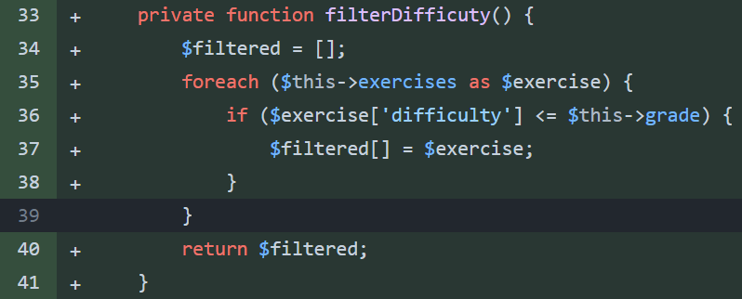The filterDifficulty function will return an array of exercises that will suit the users grade. By going through each exercise in the exercise array and appending, any exercises with a difficlty less than or equal to the user grade, to a new array called $filtered. This array is returned after all exercises have been filtered.

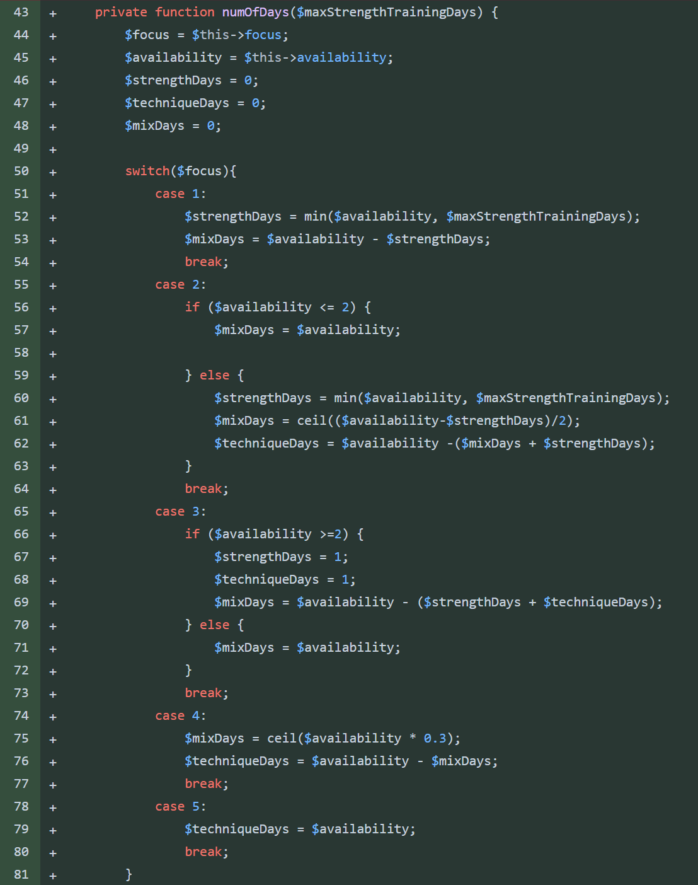The numOfDays() function will setup variables the algorithm need in order to create the plan. The variables are:

* $strengthDays
* $techniqueDays
* MixDays

These are each assigned an interger value depending on the users focus and avaliability. If a user has a high strength fous they will be given more strength days and less or no technique days. A user with a balanced focus may have a mix of all 3 days. A user with 5 days avaliabilty and a max strength focus will still be given mixed days since there is a constant of 3 max strength days a week.

I decided to use a switch since they are slightly more optimised vs multiple ifelse statements. Personally switches are also cleaner and easier to read also.

The switch will choose the corect case depending on the users focus and then using the case and the users avaliabilty the number of each day is worked out.

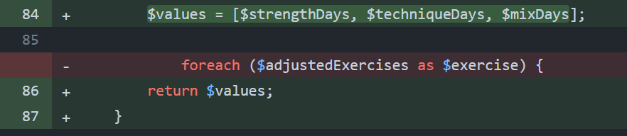To return the values I added them to an array and returned the array. This is the procedural solution to the problem I had above with returning multiple values from a function.

The exerciseArrays() function will return 3 separate arrays each with different exercises. For example array 1 contains only strength training exercises.